|  |  |
| --- | --- |
| 3GPP TR 38.871 V18.0.0 (2023-12) | |
| Technical Report | |
| 3rd Generation Partnership Project;  Technical Specification Group Radio Access Network;  NR;  Study on NR frequency range 2 (FR2) Over-the-Air (OTA) testing enhancements;  (Release 18) | |
|  | |
| *5G-logo_175px* | 3GPP-logo_web |
|  | |
| The present document has been developed within the 3rd Generation Partnership Project (3GPP TM) and may be further elaborated for the purposes of 3GPP. The present document has not been subject to any approval process by the 3GPPOrganizational Partners and shall not be implemented. This Specification is provided for future development work within 3GPPonly. The Organizational Partners accept no liability for any use of this Specification. Specifications and Reports for implementation of the 3GPP TM system should be obtained via the 3GPP Organizational Partners' Publications Offices. | |

|  |
| --- |
|  |
| ***3GPP***  Postal address  3GPP support office address  650 Route des Lucioles - Sophia Antipolis  Valbonne - FRANCE  Tel.: +33 4 92 94 42 00 Fax: +33 4 93 65 47 16  Internet  http://www.3gpp.org |
| ***Copyright Notification***  No part may be reproduced except as authorized by written permission. The copyright and the foregoing restriction extend to reproduction in all media.  © 2023, 3GPP Organizational Partners (ARIB, ATIS, CCSA, ETSI, TSDSI, TTA, TTC).  All rights reserved.  UMTS™ is a Trade Mark of ETSI registered for the benefit of its members  3GPP™ is a Trade Mark of ETSI registered for the benefit of its Members and of the 3GPP Organizational Partners LTE™ is a Trade Mark of ETSI registered for the benefit of its Members and of the 3GPP Organizational Partners  GSM® and the GSM logo are registered and owned by the GSM Association |

Contents

Foreword 5

1 Scope 7

2 References 7

3 Definitions of terms, symbols and abbreviations 8

3.1 Terms 8

3.2 Symbols 8

3.3 Abbreviations 8

4 General 9

4.1 Objective 9

4.2 Devices Type 9

5 UE RF testing methodology for multi-Rx chain DL reception 10

5.1 General 10

5.2 Measurement setup 10

5.2.1 Measurement Setup with Full Degree of Rotation Freedom for Each AoA 10

5.2.2 Measurement Setup with Full Degrees of Freedom for AoA1 with Fixed Angular Offset(s) Between AoA1 and AoA2 19

5.2.3 Measurement Setup with Full Degrees of Freedom for AoA1 with Variable Angular Offset(s) between AoA1 and AoA2 24

5.2.4 Measurement Setup with Full Degrees of Freedom for AoA1 with Partial Freedom of Variable Angular Offset(s) between AoA1 and AoA2 26

5.2.5 Measurement Setup with Full Degrees of Freedom for AoA1 with Fixed AoA2/Anchor in NF 28

5.2.6 Measurement Setup with Test Modes 29

5.2.7 Measurement Setup to reduce sensitivity to UE orientation in holder with full degrees of freedom for AoA1 with fixed angular offset(s) between AoA1 and AoA2 30

5.2.7.1 Background and Motivation 30

5.2.7.2 Implementation Direction 32

5.2.7.3 Scan strategy to avoid source blocking 35

5.2.7.4 Pros and Cons 38

5.3 Test System Aspects 39

5.3.1 Absolute Probe Locations 39

5.3.2 Minimum and Maximum Angular Separation between Probes 41

5.3.3 Impact of Probe Locations and 3D Scans on DL Directions 44

5.3.4 DL Polarizations Perceived by the UE 57

5.3.5 AoA1-AoA2 DL Orientation Vectors 68

5.3.6 Far-field criteria 74

5.4 Calibration Measurement Procedure 74

5.4.1 Direct far field (DFF) 74

5.4.2 Indirect far field (IFF) 74

5.5 Test procedure 75

6 UE RRM testing methodology for multi-Rx chain DL reception 77

6.1 General 77

6.2 Measurement setup 77

6.2.1 Baseline measurement setup 77

6.2.1.1 Test scenarios 77

6.2.1.2 Measurement setup for Category 1 scenario 77

6.2.1.3 Measurement setup for Category 2 scenario 78

6.2.1.4 Far-field criteria 81

6.2.1.5 Calibration measurement procedure 81

6.2.1.6 Reference point 81

6.2.2 Test parameters 82

6.2.2.1 Test parameters for Mode 1 82

6.2.2.2 Test parameters for Mode 2 82

7 UE demodulation and CSI testing methodology for multi-Rx chain DL reception 83

7.1 General 83

7.2 Measurement setup 83

7.2.1 Baseline measurement setup 83

7.2.1.1 Reference point 83

7.2.1.2 Far-field criteria 83

7.2.1.3 Calibration measurement procedure 83

7.2.2 Test parameters 84

7.2.2.1 Noc level configuration 84

7.2.2.2 Criteria of UE test directions 84

8 Summary 84

Annex A: Measurement uncertainty 86

A.1 Measurement uncertainty budget for UE RF testing methodology 86

A.2 Measurement uncertainty budget for UE RRM testing methodology 88

A.3 Measurement uncertainty budget for UE demodulation testing methodology 89

Annex B: UE coordinate system 91

B.1 Reference coordinate system 91

B.2 Alternate coordinate system for 2AoA testing 92

B.3 Test conditions and angle definitions 94

B.4 DUT positioning guidelines 99

Annex G: Step size of measurement grids 99

G.1 Simulation results for step size 100

Annex H: Change history 102

# Foreword

This Technical Report has been produced by the 3rd Generation Partnership Project (3GPP).

The contents of the present document are subject to continuing work within the TSG and may change following formal TSG approval. Should the TSG modify the contents of the present document, it will be re-released by the TSG with an identifying change of release date and an increase in version number as follows:

Version x.y.z

where:

x the first digit:

1 presented to TSG for information;

2 presented to TSG for approval;

3 or greater indicates TSG approved document under change control.

y the second digit is incremented for all changes of substance, i.e. technical enhancements, corrections, updates, etc.

z the third digit is incremented when editorial only changes have been incorporated in the document.

In the present document, modal verbs have the following meanings:

**shall** indicates a mandatory requirement to do something

**shall not** indicates an interdiction (prohibition) to do something

The constructions "shall" and "shall not" are confined to the context of normative provisions, and do not appear in Technical Reports.

The constructions "must" and "must not" are not used as substitutes for "shall" and "shall not". Their use is avoided insofar as possible, and they are not used in a normative context except in a direct citation from an external, referenced, non-3GPP document, or so as to maintain continuity of style when extending or modifying the provisions of such a referenced document.

**should** indicates a recommendation to do something

**should not** indicates a recommendation not to do something

**may** indicates permission to do something

**need not** indicates permission not to do something

The construction "may not" is ambiguous and is not used in normative elements. The unambiguous constructions "might not" or "shall not" are used instead, depending upon the meaning intended.

**can** indicates that something is possible

**cannot** indicates that something is impossible

The constructions "can" and "cannot" are not substitutes for "may" and "need not".

**will** indicates that something is certain or expected to happen as a result of action taken by an agency the behaviour of which is outside the scope of the present document

**will not** indicates that something is certain or expected not to happen as a result of action taken by an agency the behaviour of which is outside the scope of the present document

**might** indicates a likelihood that something will happen as a result of action taken by some agency the behaviour of which is outside the scope of the present document

**might not** indicates a likelihood that something will not happen as a result of action taken by some agency the behaviour of which is outside the scope of the present document

In addition:

**is** (or any other verb in the indicative mood) indicates a statement of fact

**is not** (or any other negative verb in the indicative mood) indicates a statement of fact

The constructions "is" and "is not" do not indicate requirements.

# 1 Scope

The objectives for FR2-1 OTA testing for UEs with multi-panel reception and 4DL layer are as follows.

- Define a test methodology for RF/RRM/Demodulation requirements testing for devices that can receive simultaneously from multiple Angle of Arrival (AoA)

- The multiple AoA test setup should enable testing of up to 2 DL Layers with dual polarization for each angle

- For RRM, the target should be to allow testing of 4 AoAs with 2 simultaneously active AoAs

- Define a test methodology for up to 4 DL MIMO layer demodulation testing

- Smartphone form factor should be the first priority, other UE types should also be discussed as 2nd priority

- Develop the related preliminary uncertainty assessments for the test methodologies

- The tests shall take the test system reuse, test system complexity and test time into account to keep the whole test costs within a reasonable level.

# 2 References

The following documents contain provisions which, through reference in this text, constitute provisions of the present document.

- References are either specific (identified by date of publication, edition number, version number, etc.) or non‑specific.

- For a specific reference, subsequent revisions do not apply.

- For a non-specific reference, the latest version applies. In the case of a reference to a 3GPP document (including a GSM document), a non-specific reference implicitly refers to the latest version of that document *in the same Release as the present document*.

[1] 3GPP TR 21.905: "Vocabulary for 3GPP Specifications".

[2] 3GPP TS 38.101-2: "User Equipment (UE) radio transmission and reception; Part 2: Range 2 Standalone".

[3] 3GPP TR 38.810: "Study on test methods".

[4] 3GPP TR 38.884: "Study on enhanced test methods for FR2 NR UEs".

[5] 3GPP TS 38.509, "Special conformance testing functions for User Equipment (UE) ".

[6] 3GPP TS 38.521-2, "User Equipment (UE) conformance specification; Radio transmission and reception; Part 2: Range 2 Standalone".

[7] 3GPP TS 38.508-1, "User Equipment (UE) conformance specification; Part 1: Common test environment".

[8] 3GPP TS 38.151, "Multiple Input Multiple Output (MIMO) Over-the-Air (OTA) performance requirements".

[9] 3GPP TR 38.884, "Study on enhanced test methods for FR2 NR UEs".

[10] 3GPP TS 38.508-1, "User Equipment (UE) conformance specification; Part 1: Common test environment".

[11] 3GPP TS 34.114: "User Equipment (UE) / Mobile Station (MS) Over The Air (OTA) antenna performance; Conformance testing".

[12] 3GPP TS 38.133: "Requirements for support of radio resource management".

[13] 3GPP TR 38.903: "Derivation of test tolerances and measurement uncertainty for User Equipment (UE) conformance test cases".

# 3 Definitions of terms, symbols and abbreviations

## 3.1 Terms

For the purposes of the present document, the terms given in 3GPP TR 21.905 [1] and the following apply. A term defined in the present document takes precedence over the definition of the same term, if any, in 3GPP TR 21.905 [1].

**Measurement angle**: the angle of measurement of the desired metric from the view point of the UE, as described in Annex B.

**RX beam peak direction**: direction where the maximum total component of RSRP and thus best total component of EIS is found.

**TX beam peak direction:** direction where the maximum total component of EIRP is found.

## 3.2 Symbols

For the purposes of the present document, the following symbols apply:

θ Zenith angle in the spherical co-ordinate system, as well as measurement antenna polarization along the direction of motion of the zenith axis rotation.

φ Azimuth angle in the spherical co-ordinate system, as well as measurement antenna polarization along the direction of motion of the azimuth axis rotation.

## 3.3 Abbreviations

For the purposes of the present document, the abbreviations given in 3GPP TR 21.905 [1] and the following apply. An abbreviation defined in the present document takes precedence over the definition of the same abbreviation, if any, in 3GPP TR 21.905 [1].

AoA Angle of Arrival

CATR Compact Antenna Test Range

DFF Direct Far Field

DUT Device Under Test

EIS Effective Isotropic Sensitivity

EIRP Effective (or equivalent) isotropic radiated power

FR2 Frequency Range IFF Indirect Far Field

MU Measurement Uncertainty

NR New Radio

NSA Non-standalone

OTA Over The Air

RSRP Reference signal receive power

SNR Signal-to-Noise Ratio

SGH Standard Gain Horn

TRP Total Radiated Power

UBF UE beam lock function

UE User Equipment

# 4 General

## 4.1 Objective

In Rel-17 WI on further enhancements on MIMO for NR (Acronym: NR\_FeMIMO), the objective is to extend the specification to support several aspects on NR MIMO including simultaneous multi-Rx chain DL reception. With considering the objective to define new requirements for the UE with multi-Rx chain DL reception, the FR2 test methods for RF, RRM and demodulation need to be enhanced. This document is to define the enhanced test methods for the verifications of these new requirements for FR2 UE with multi-Rx chain DL receptions.

## 4.2 Devices Type

The following device types are considered in the scope of this study:

- Smartphone

- Tablet

- Wearable devices

- Vehicular mounted device

- Fixed Wireless Access (FWA) terminal

- Other UE types are not precluded

The development of test methods shall initially focus on the smartphone device type. Other UE types should also be studied as 2nd priority.

# 5 UE RF testing methodology for multi-Rx chain DL reception

## 5.1 General

This clause describes the UE RF testing methodology for multi-Rx chain DL reception for FR2. The following candidate measurement setups are investigated:

- Measurement Setup with Full Degree of Rotation Freedom for Each AoA

- Measurement Setup with Full Degrees of Freedom for AoA1 with Fixed Angular Offset(s) Between AoA1 and AoA2

- Measurement Setup with Full Degrees of Freedom for AoA1 with Variable Angular Offset(s) between AoA1 and AoA2

- Measurement Setup with Full Degrees of Freedom for AoA1 with Partial Freedom of Variable Angular Offset(s) between AoA1 and AoA2

- Measurement Setup with Full Degrees of Freedom for AoA1 with Fixed AoA2/Anchor in NF

- Measurement Setup with Test Modes

- Measurement Setup to reduce sensitivity to UE orientation in holder with full degrees of freedom for AoA1 with fixed angular offset(s) between AoA1 and AoA2

Through the analysis of system complexity, chamber footprint, upgradeability of existing system, development lead time, measurement uncertainty, and test time aspects, the measurement setup with full degrees of freedom for AoA1 with fixed angular Offset(s) between AoA1 and AoA2 is selected as the baseline in Rel-18.

## 5.2 Measurement setup

### 5.2.1 Measurement Setup with Full Degree of Rotation Freedom for Each AoA

FR2 OTA measurement setups with full degree of rotation freedom for each AoA support two simultaneous AoAs with any combination of DL directions, i.e., any permutation of possible AoAs shall be supported. This setup was initially considered as the preferred measurement setup for multi-AoA UE RF testing but later discarded for reasons outlined below.

Such setup was also considered the default measurement setup for FR2 UE RF testing during the SI phase of FR2 OTA testing [3] given the requirement to perform off-centre of beam measurements as illustrated in Figure 5.2.1-1. However, the adoption of the UE Beamlock test Function (UBF), see Clause 5.4 of [5], to readily perform off-centre of beam measurements shifted the focus towards more practical single-AoA/single-probe UE RF setups, e.g., the Indirect Far Field (IFF) methodology [3] which subsequently became the de-facto setup for FR2 UE RF testing.



Figure 5.2.1-1: DFF measurement setup of UE RF characteristics for TRP scans (Figure 5.2.1.1-1 of [3]).

Measurement setups that allow arbitrary positioning for each probe, i.e., the UE does not necessarily require a positioning system are illustrated in Figure 5.2.1-2 and Figure 5.2.1-3. The Direct Far Field (DFF) methodology, i.e., millimeter-wave measurement probes placed in the far-field away from the DUT when adapted to two-simultaneous AoA testing, is illustrated in Figure 5.2.1-2. Here, the probes introducing AoA1 (beam shown in blue) and AoA2 (beam shown in red) can be positioned arbitrarily while the DUT is fixed. When the DFF probes are replaced with Indirect Far Field (IFF) probes, i.e., measurement probe and reflector, a sample test system with full degrees of freedom for each AoA is shown in Figure 5.2.1-3. The full degree of rotation freedom for each probe is highlighted with the yellow arrows behind each DFF probe/IFF probe&reflector combination. The positioning requirements to accurately position probe(s) along two principal axes in 3D yield a very high positioning complexity.



Figure 5.2.1-2: Example DFF measurement setup for two-simultaneous AoA testing with full degrees of freedom for each probe.



Figure 5.2.1-3: Example IFF measurement setup for two-simultaneous AoA testing with full degrees of freedom for each probe.

Size (width/depth/height) estimations performed for such DFF/IFF systems supporting the FR2-1 frequency range and devices up to a 40 cm diameter (40 cm QZ) are tabulated in Table 5.2.1-1. The increase in chamber sizes (footprint and heights) when compared to existing FR2 UE RF chambers is significant and existing chambers are not upgradable to support full degrees of freedom. The lead times to develop such systems with full degrees of freedom could be quite significant and could thus delay the commercial adoption of these test cases. Additionally, the overall system complexities of such systems could further require an increase in measurement uncertainties (MUs) and thus test tolerances (TTs).

Table 5.2.1-1: Size estimates for UE RF systems with full degrees of freedom for each probe.

|  |  |  |  |
| --- | --- | --- | --- |
| Size  Test Method | Width [m] | Depth [m] | Height [m] |
| DFF | 3.2 | 3.2 | 3.2 |
| IFF | 4.4 | 4.4 | 4.4 |

Measurement setups that allow full degrees of positioning freedom for one probe and the DUT while the other probe is fixed are shown in Figure 5.2.1-4 for the DFF and Figure 5.2.1-5 for the IFF methodology. The probe introducing AoA1 (beam shown in blue) is fixed while the DUT and the probe introducing AoA2 (beam shown in red) can be positioned arbitrarily (as indicated with the yellow arrows). This approach therefore also supports full degrees of rotational freedom for each AoA.



Figure 5.2.1-4: Example DFF measurement setup for two-simultaneous AoA testing with arbitrary positioning capability for one probe and DUT supporting full degrees of freedom.

Size (width/depth/height) estimations were performed for such DFF/IFF systems as well which are tabulated in Table 5.2.1-2. Only a very small improvement in footprint, i.e., width, can be observed for this system architecture when compared to Table 5.2.1-1. The same conclusions/observations can be made as those above, i.e., the increase in chamber sizes (footprint and heights) when compared to existing FR2 UE RF chambers is significant and existing chambers are not upgradable to support full degrees of freedom.



Figure 5.2.1-5: Example IFF measurement setup for two-simultaneous AoA testing with full degrees of freedom for one probe & DUT

Table 5.2.1-2: Size estimates for UE RF systems with full degrees of freedom for each probe.

|  |  |  |  |
| --- | --- | --- | --- |
| Size  Test Method | Width [m] | Depth [m] | Height [m] |
| DFF | 3.2 | 3.2 | 3.2 |
| IFF | 4.4 | 4.4 | 4.4 |

Alternate example measurement setups to support full degrees of freedom for AoA are shown in Figures 5.2.1-6 through 5.2.1-9.

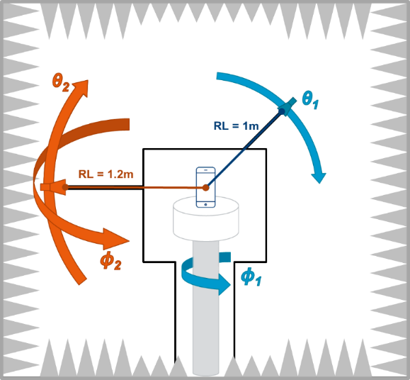

Figure 5.2.1-6: Example of 2AoA DFF test system with full degrees of freedom

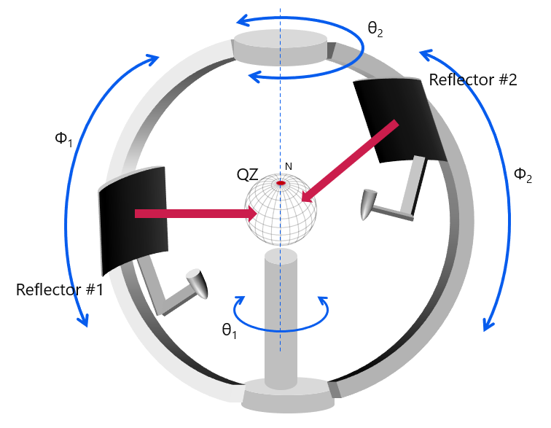

Figure 5.2.1-7: Distributed-axes system with two moving IFF reflectors

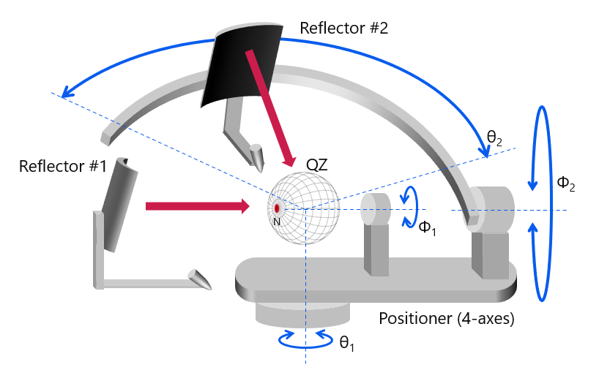

Figure 5.2.1-8: Distributed-axes system with two moving IFF reflectors

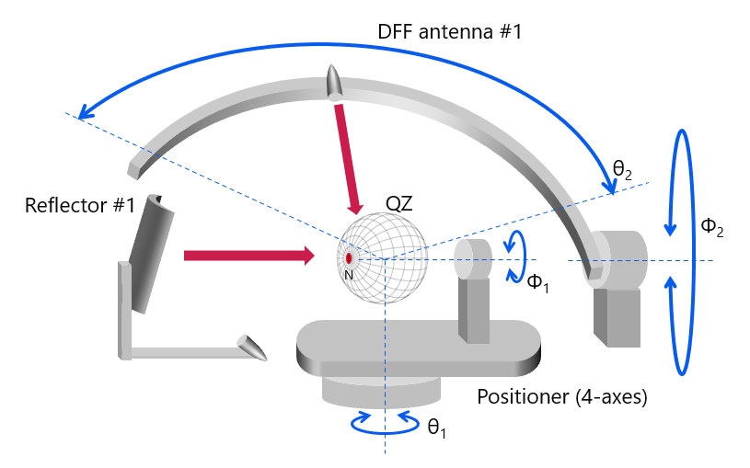

Figure 5.2.1-9: 2AoA RF test system with DFF antenna as the second NR anchor on a slider

The full degrees of freedom for each AoA supports a probe offset option with variable angular offset(s) between AoA1 and AoA2 in the chamber. The angular separation between AoA1 and AoA2 can change during the testing. This is further illustrated with a sample DUT with a beam peak in the DUT *y* direction, as illustrated in Figure 5.2.1-10. As the AoA2 probe has full degrees of freedom, i.e., the angular difference between AoA1 and AoA2 is arbitrary, the AoA2 probe can track/follow the DUT’s beam peak during testing as illustrated in Table 5.2.1-3 for two different DUT orientations/test points.

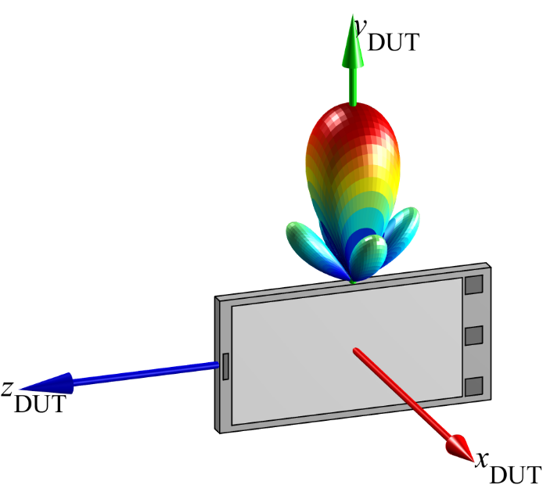

Figure 5.2.1-10: Sample DUT with assumed beam peak in the DUT’s *y* direction

Table 5.2.1-3: Ability of tracking a DUT reference direction

|  |  |
| --- | --- |
| DUT Orientation  (q, f) | Offset Option: variable angular offset(s) between AoA1 and AoA2 |
| (0°, 0°) |  |
| (45°, -45°) |  |

Efforts for multi-AoA DL spherical coverage testing based on the assumptions that no prior knowledge of the performance of any panel/chain is available, e.g., beam peak directions of each panel, are significant and quantified next. The spherical coverage test for any multi-chain UE system configuration would require a spherical coverage test with *N*\*(*N*-1)≈*N*2 AoA combinations. Here, *N* is the minimum number of spherical coverage grid points. The effort in terms of minimum number of test points is quantified in Table 5.2.1-4 assuming that the same measurement grids/grid density are used as for legacy spherical coverage testing, defined in Clause M.3 of [6].

Table 5.2.1-4: Test Effort Estimates for UE RF Systems with Full Degrees of Freedom for AoA.

|  |  |  |  |
| --- | --- | --- | --- |
| Power Class | Grid Type | Minimum Number of Spherical Coverage Test Points *N* (single chain) as defined in M.3 of Error! Reference source not found. | Number of Spherical Coverage Test Points *N* (multi chain)  *N*\*(*N*-1) |
| PC1 | constant density | 200 | 39,800 |
| PC3 | constant density | 180 | 32,220 |
| PC1/PC3 | constant-step size | 266 | 70,490 |

The number of test points for this test approach is test time prohibitive given the very large number of test points.

This measurement setup has its pros/cons summarized in Table 5.2.1-5.

Table 5.2.1-5: Overview of Measurement Setup

|  |  |
| --- | --- |
| Description | Full degrees of freedom for both AoAs |
| Probe Offset Option | Variable Angular Offset(s) between AoA1 and AoA2 in the chamber. The angular separation between AoA1 and AoA2 can change during the testing |
| Pros | - AoA2 can follow/track a specific reference direction |
| Cons | - Very high system complexity  - Existing systems cannot be re-used  - Large/very large chamber footprint/chamber heights  - Long development time/TTM  - Increase in MU/TT |

When the AoA2 probe/anchor probe is placed in the NF while supporting variable angular offsets, different system aspects must be taken into account. A sample measurement setup is shown in Figure 5.2.1-11 where both AoA1 (in FF) and AoA2 (in NF) have full degrees of freedom.

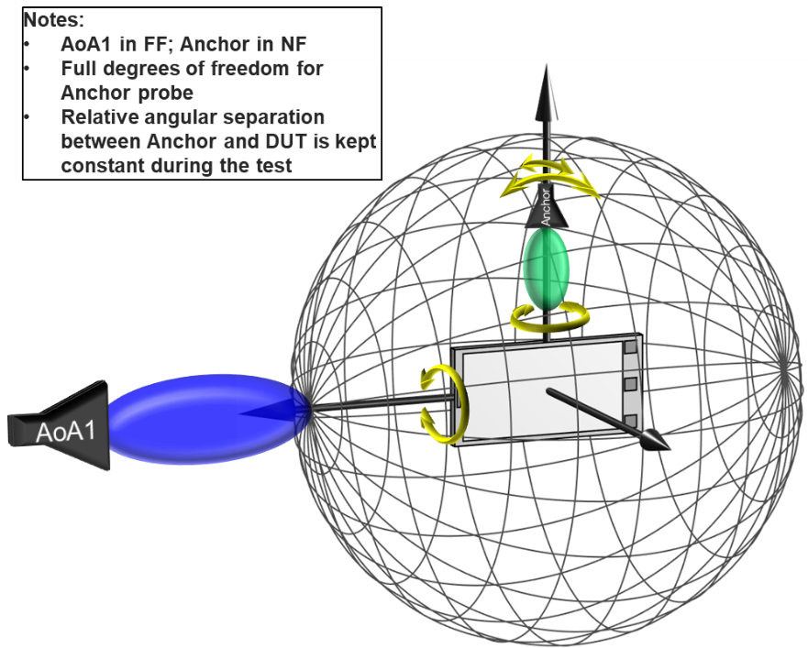

Figure 5.2.1-11: Example Measurement Setup with AoA2/Anchor in NF

An example implementation with the anchor probe mounted to the roll motor with independent positioning control (purple arrows) is shown in Figure 5.2.1-12.

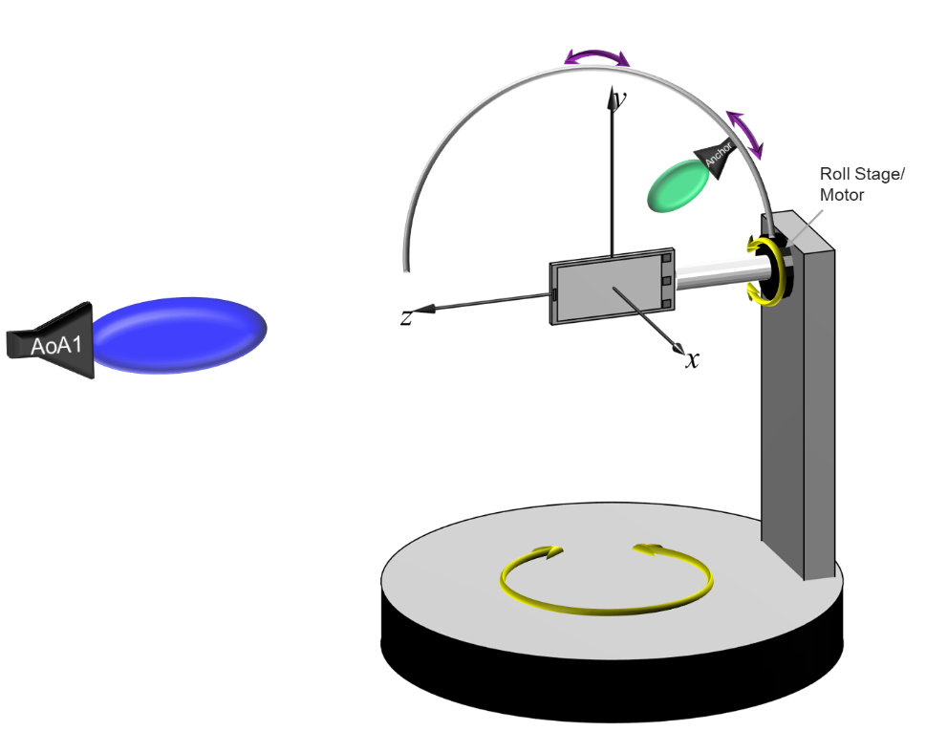

Figure 5.2.1-12: Example Implementation of Measurement Setup with AoA2/Anchor in NF

It should be noted that link antennas used in existing systems commonly do not have completely independent positioning control to support the full degrees of freedom. Link antennas are traditionally used to introduce an auxiliary communication link between the gNB and the DUT to avoid poor signal conditions in the non-tested DL or UL (for UL or DL measurements) and thus dropped calls. As no calibrated measurements are performed over this link, this signal path is generally never calibrated and the positioning and link probe requirements are very relaxed, e.g., large positioning uncertainty of the link antenna are acceptable, and the link antenna can be a low performance antenna coupler. Hence, such link antenna setups are not suitable for UE RF measurements.

In [9], NF methodologies for single-UL and DL were investigated and eventually considered permitted methodologies for FR2 test cases that currently require large relaxations in RAN5 technical specifications. The EIS/EIRP measurements in the immediate NF require very accurate positioning of the NF probe, a high-end antenna probe, and the NF antenna pattern characterization. Given the need for accurate positioning and relatively large NF probe antennas supporting two principal polarizations, antenna(s) and fixturing will result in significant blocking in various AoA1 measurement directions. More importantly, to accurately determine EIS in the NF, it is required to calibrate out the offset of the active DUT antenna from the centre of QZ to account for the correct path loss between the NF measurement probe and the active antenna. This offset can either be determined using a set of measurements which need to be performed for each AoA1 measurement direction (black box approach of CFFNF in Clause 5.1.4 of [9]) or based on a rather extensive vendor declaration, e.g., location of all antenna panels and which antenna is active for any given measurement direction. Applying these NF findings to multi-Rx UE RF testing has the following implications:

- The vendor declaration would require the exact location of all active antenna pairs for each AoA2 probe direction, i.e., an even more extensive vendor declaration than for single DL EIS measurements

- The NF probe needs to guarantee the same DL conditions to both active DUT receivers as a FF probe would since UE RF requirements are defined in the FF

This measurement setup has its pros/cons summarized in Table 5.2.1-6.

Table 5.2.1-6: Overview of Measurement Setup with AoA2 Probes in the NF

|  |  |
| --- | --- |
| Description | Full Degrees of Freedom for AoA1 and AoA2 with AoA2 Probe in NF |
| Probe Offset Option | Variable Angular Offset(s) between AoA1 and AoA2 in the chamber. The angular separation between AoA1 and AoA2 can change during the testing |
| Pros | - Existing systems could potentially be re-used after some modifications |
| Cons | - Blocking of AoA1 in various directions by AoA2 probes  - Existing link antennas are not applicable; instead, very accurate positioning of the NF probe(s), high-end antenna probe(s), and the NF antenna pattern characterization are required  - Test-time intensive algorithms required to determine unknown offset of active antenna array(s) *or*  - Very extensive vendor declarations (location of all antenna panels and which sets of antenna panels are active for any given AoA2 measurement direction)  - The NF probe needs to guarantee the same DL conditions to both active DUT receivers as a FF probe would |

### 5.2.2 Measurement Setup with Full Degrees of Freedom for AoA1 with Fixed Angular Offset(s) Between AoA1 and AoA2

An alternate measurement setup considered for multi-AoA UE RF testing is based on full degrees of freedom for AoA1 with fixed angular offsets between AoA1 and AoA2 with the angular separations between AoA1 and AoA2(s) not changing during the testing. Example measurement setups are illustrated in Figure 5.2.2-1 where the (fixed) probe locations, the number of probes, and probe type (DFF, IFF) were selected arbitrarily.

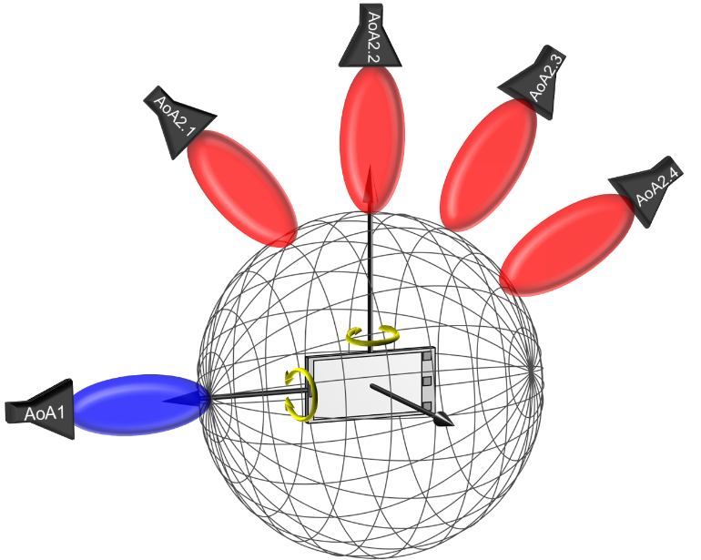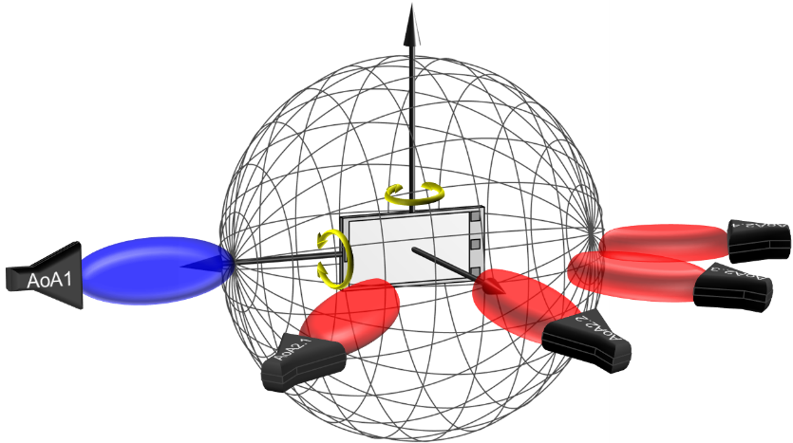

Figure 5.2.2-1: Example measurement setups for two-simultaneous AoA testing supporting 3D AoAs for the 1st DL direction and discrete, fixed AoAs for the 2nd DL direction. Top: probes in the vertical plane, Bottom: probes in the horizontal plane.

This multi-AoA measurement setup is similar to baseline setups for 2 AoA RRM testing [7], see Clause B.2, as illustrated in Figure 5.2.2-2 or FR2 MIMO testing [8], see Clause B.2, as illustrated in Figure 5.2.2-3.







Figure 5.2.2-2: Example RRM baseline system with two simultaneously active AoA using top: DFF setup, centre: Enhanced IFF setup, bottom: IFF+DFF setup.

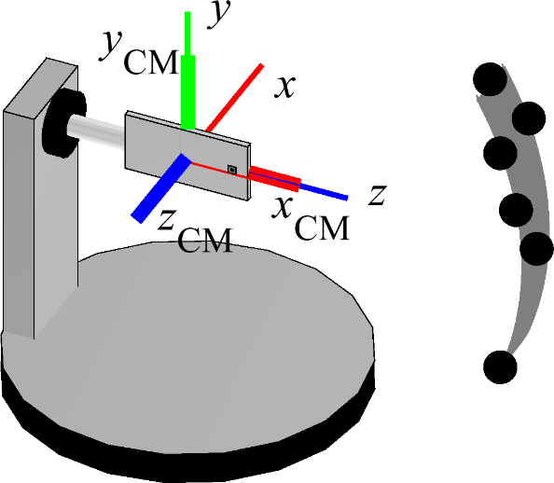

Figure 5.2.2-3: Example FR2 MIMO OTA 3D-MPAC system.

Due to the fixed offset between AoAs, the AoA2 probe cannot track/follow a DUT’s reference direction, e.g., beam peak, during testing as illustrated in Table 5.2.2-1 for two different DUT orientations/test points.

Table 5.2.2-1: Lack of ability of tracking a DUT reference direction

|  |  |
| --- | --- |
| DUT Orientation  (q, f) | Offset Option: fixed angular offset(s) between AoA1 and AoA2 |
| (0°, 0°) |  |
| (45°, -45°) |  |

This measurement setup has its pros/cons summarized in Table 5.2.2-2.

Table 5.2.2-2: Overview of Measurement Setup

|  |  |
| --- | --- |
| Description | Full degrees of freedom for AoA1 with fixed angular offset(s) between AoA1 and AoA2 |
| Probe Offset Option | Fixed Angular Offset(s) between AoA1 and AoA2 in the chamber. The angular separation between AoA1 and AoA2 is NOT changing during the testing |
| Pros | - System complexity is manageable  - Existing systems, e.g., 2 AoA FR2 RRM, can be re-used (as long as common AoA2 probe locations are defined)  - Small chamber footprint/chamber heights  - Little to no development time/TTM  - Little to no impact in MU  - Multiple AoA1/AoA2 combinations can be tested  - A wide range of angular difference between AoA1 and AoA2 can readily be tested  - IFF methodology can be applied for each AoA probe for lowest MU and widest applicability. |
| Cons | - AoA2 cannot follow/track a specific reference direction |

This measurement setup was selected the baseline for multi-AoA UE RF testing.

### 5.2.3 Measurement Setup with Full Degrees of Freedom for AoA1 with Variable Angular Offset(s) between AoA1 and AoA2

An alternate measurement setup considered for multi-AoA UE RF testing is based on full degrees of freedom for AoA1 with variable angular offsets between AoA1 and AoA2. At least one of the probes must utilize a 2-axis positioning system for full degrees of freedom as illustrated in Figure 5.2.3-1. The analyses for such system setup are very similar to the systems with full degrees of freedom for two AoAs in Clause 5.2.1.

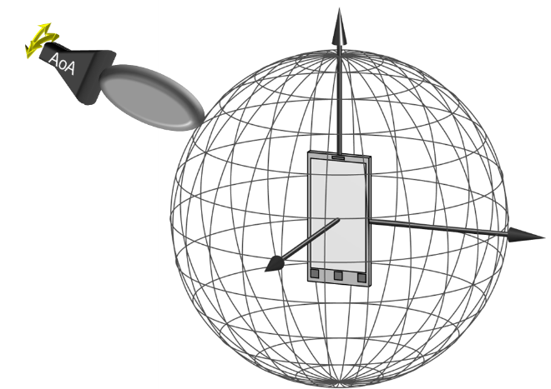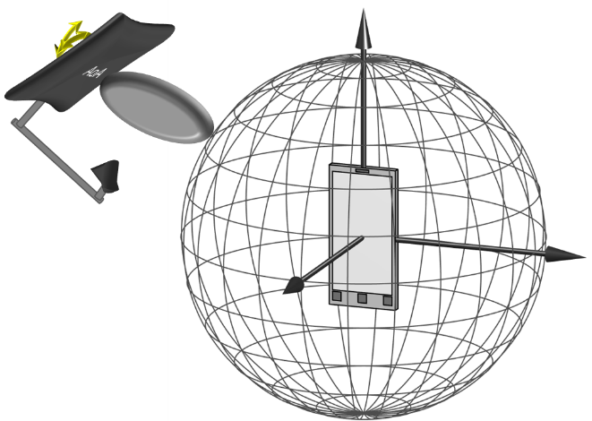

Figure 5.2.3-1: Example DFF (left)/IFF (right) measurement setup to support full degrees of freedom with two-axis positioning system for one probe.

The positioning requirements to accurately position a probe along two principal axes in 3D yield a very high positioning complexity. A sample measurement setup is shown in Figure 5.2.3-2. The system implementation with AoA1 supporting the 2-axis positioner and with a single or multiple AoA2 probe(s) require very large systems since AoA2 probe(s) must be placed behind AoA1 probe as shown in Figure 5.2.3-3 to support free movement of AoA1 and no interference with AoA2.

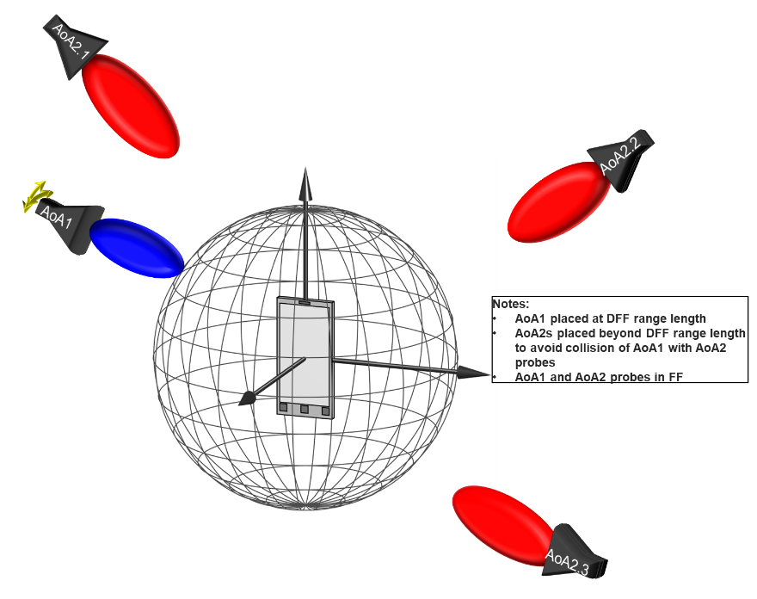

Figure 5.2.3-2: Example DFF measurement setup with full degrees of freedom for AoA1 with variable angular offset(s) between AoA1 and AoA2.

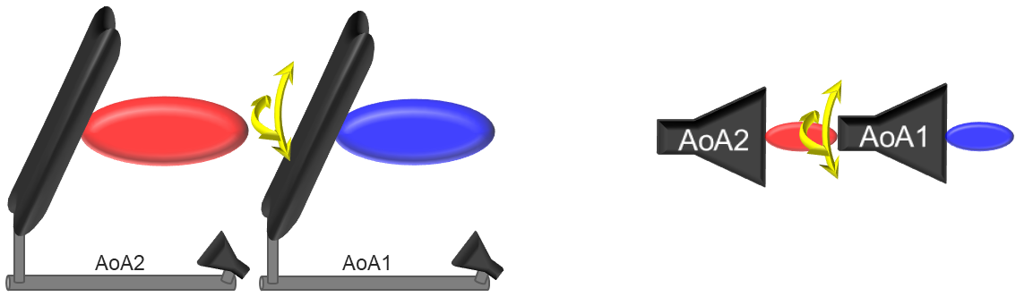

Figure 5.2.3-3: Illustration of IFF (left)/DFF (right) back-to-back probe placement.

Size (width/depth/height) estimations for such DFF/IFF systems supporting the FR2-1 frequency range and devices up to a 40 cm diameter (40 cm QZ) are tabulated in Table 5.2.3-1. The increase in chamber sizes (footprint and heights) when compared to existing FR2 UE RF chambers is significant and existing chambers are not upgradable to support full degrees of freedom. The lead times to develop such systems with full degrees of freedom could be quite significant and could thus delay the commercial adoption of these test cases. Additionally, the overall system complexities of such systems could further require an increase in measurement uncertainties (MUs) and thus test tolerances (TTs).

Table 5.2.3-1: Size estimates for UE RF systems with Full Degrees of Freedom for AoA1 with Variable Angular Offset(s) between AoA1 and AoA2.

|  |  |  |  |
| --- | --- | --- | --- |
| Size  Test Method | Width [m] | Depth [m] | Height [m] |
| DFF | 3.6 | 3.6 | 3.6 |
| IFF | 6.6 | 6.6 | 6.6 |

This measurement setup has its pros/cons summarized in Table 5.2.3-2.

Table 5.2.3-2: Overview of Measurement Setup with Probes in the FF

|  |  |
| --- | --- |
| Description | Full Degrees of Freedom for AoA1 with Variable Angular Offset(s) between AoA1 and AoA2 with Probes in FF |
| Probe Offset Option | Variable Angular Offset(s) between AoA1 and AoA2 in the chamber. The angular separation between AoA1 and AoA2 is changing during the testing |
| Pros | - The link/measurement conditions of AoA2 can be fixed during the testing |
| Cons | - AoA2 cannot follow/track a specific reference direction  - Very high system complexity  - Existing systems cannot be re-used  - Large/very large chamber footprint/chamber heights  - Long development time/TTM  - Increase in MU/TT |

### 5.2.4 Measurement Setup with Full Degrees of Freedom for AoA1 with Partial Freedom of Variable Angular Offset(s) between AoA1 and AoA2

An alternate measurement setup considered for multi-AoA UE RF testing is based on full degrees of freedom for AoA1 with partial freedom of variable angular offsets between AoA1 and AoA2.

When all AoA1 and AoA2 probes are located in the Far Field (FF), the system complexity becomes manageable for the AoA2 positioner as AoA2 does not need to support full degrees of freedom; given the potentially large radial movements of AoA2 probe(s), the positioning complexities can still be pretty significant. A sample system is shown Figure 5.2.4-1 where the AoA1 and AoA2 probes need to be displaced from each other to avoid collisions, i.e., the chamber size estimates need to take the back-to-back probe placement illustrated in Figure 5.2.3-3 into account. As such, the size estimates with all probes in the FF are likely in the order of those listed in Table 5.2.3-1. This setup (with all probes in the FF) requires very large chambers, rather complex positioning needs for AoA2, lacks the ability to re-use existing test systems, and likes yields an increase of MUs and TTs.

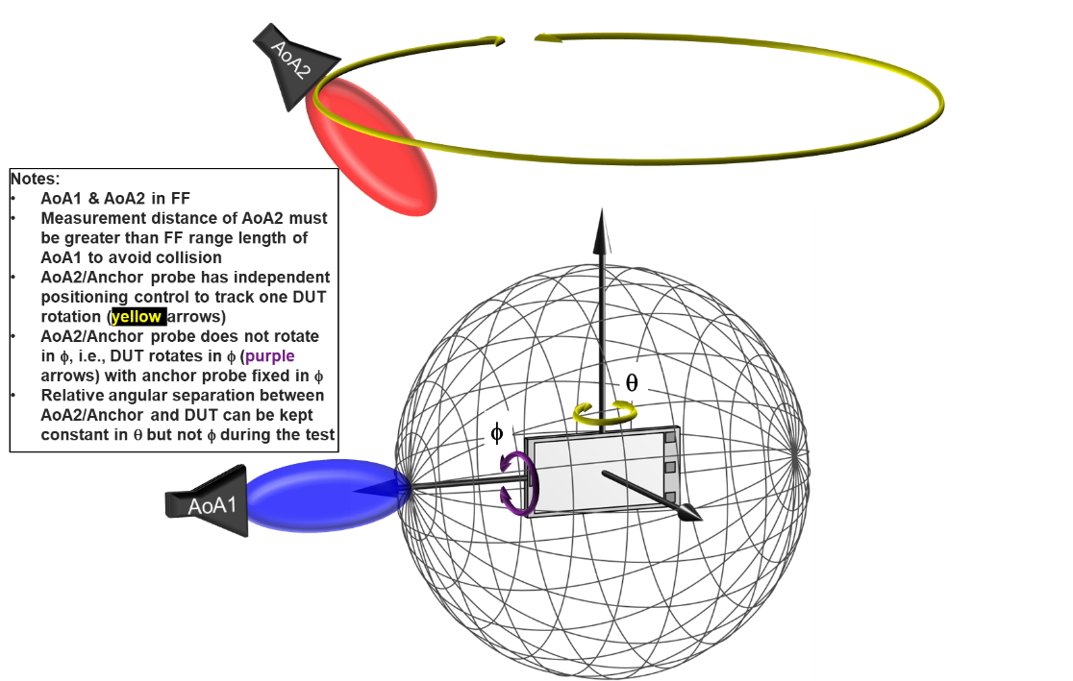

Figure 5.2.4-1: Example DFF measurement setup with full degrees of freedom for AoA1 with partial freedom of variable angular offset(s) between AoA1 and AoA2 with AoA2 in FF.

When AoA2 probes are placed in the NF of the DUT, e.g., using one or multiple link antennas as illustrated in the example illustration in Figure 5.2.4-2, similar aspects considered in the previous section apply here. The immediate seemingly advantage is that existing test systems could be used with some modifications to link antenna setups. However, as outlined in Clause 5.2.1, there are various disadvantages and testing considerations that need to be taken into account when the AoA2/anchor probe is in the NF

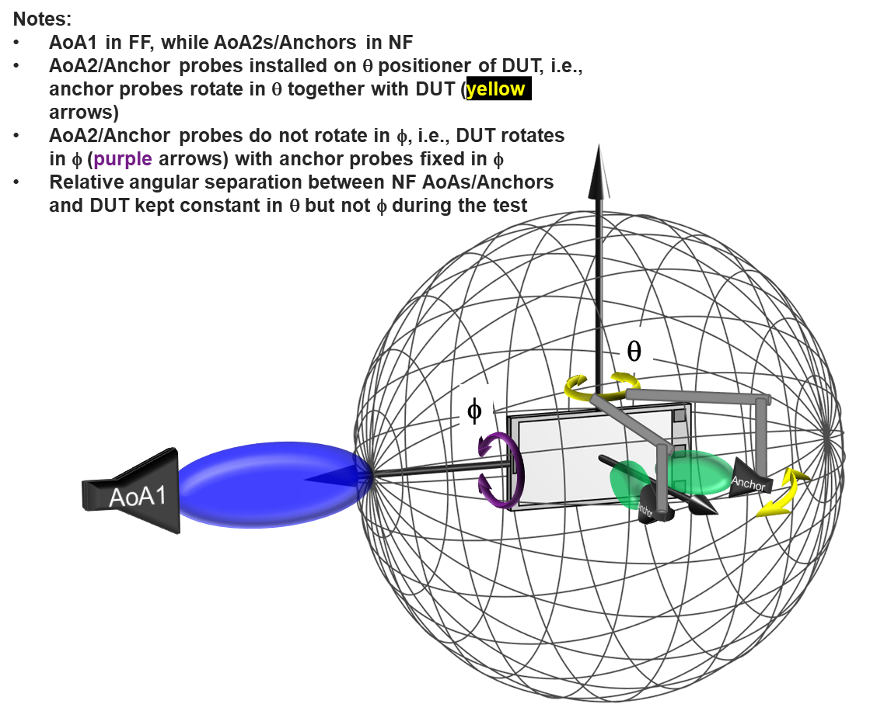

Figure 5.2.4-2: Example DFF measurement setup with full degrees of freedom for AoA1 with partial freedom of variable angular offset(s) between AoA1 and AoA2 with AoA2 in NF.

This measurement setup has its pros/cons summarized in Table 5.2.4-1.

Table 5.2.4-1: Overview of Measurement Setup

|  |  |
| --- | --- |
| Description | Measurement Setup with Full Degrees of Freedom for AoA1 with Partial Freedom of Variable Angular Offset(s) between AoA1 and AoA2 |
| Probe Offset Option | Full degrees of freedom for AoA1 with partial freedom of variable angular offset(s) between AoA1 and AoA2, e.g., relative angular separation between anchor and DUT kept constant in q but not f) |
| Pros | **AoA1 & AoA2 probes in the FF**  - N/A  **AoA1 in FF with AoA2 probe(s)s in the NF**  - Existing systems could potentially be re-used after some modifications |
| Cons | **AoA1 & AoA2 probes in the FF**  - High system complexity  - Existing systems cannot be re-used  - Large/very large chamber footprint/chamber heights  - Long development time/TTM  - AoA2 cannot follow/track a specific reference direction  **AoA1 in FF with AoA2 probe(s)s in the NF**  - Blocking of AoA1 in various directions by AoA2 probes  - Existing link antennas are not applicable; instead, very accurate positioning of the NF probe(s), high-end antenna probe(s), and the NF antenna pattern characterization are required  - Test-time intensive algorithms required to determine unknown offset of active antenna array(s) *or*  - Very extensive vendor declarations (location of all antenna panels and which sets of antenna panels are active for any given AoA2 measurement direction)  - The NF probe needs to guarantee the same DL conditions to both active DUT receivers as a FF probe would  - AoA2 cannot follow/track a specific reference direction |

### 5.2.5 Measurement Setup with Full Degrees of Freedom for AoA1 with Fixed AoA2/Anchor in NF

An alternate measurement setup considered for multi-AoA UE RF testing is based on full degrees of freedom for AoA1 with fixed AoA2/Anchor located in the NF, sample measurement setups are shown in Figure 5.2.5-1.

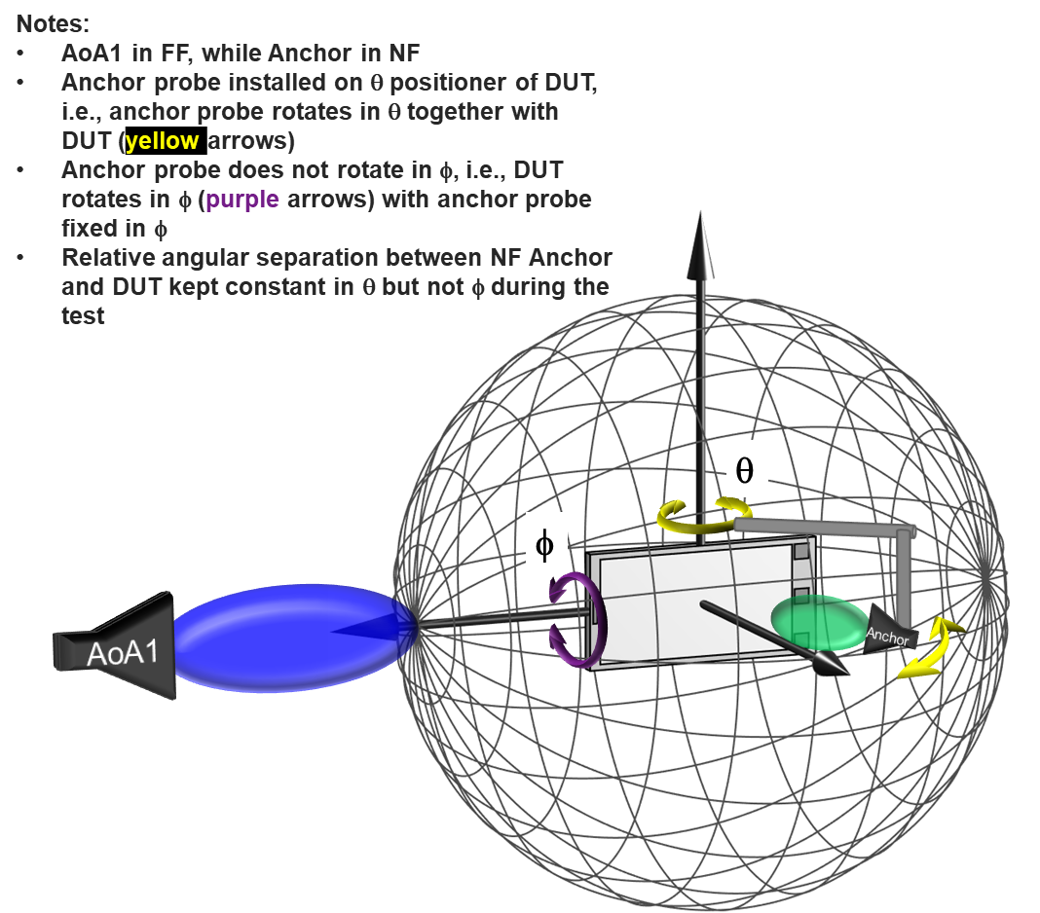

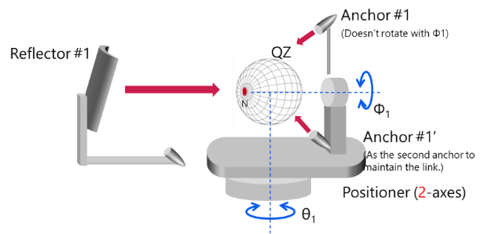

Figure 5.2.5-1: Example measurement setups with full degrees of freedom for AoA1 with fixed AoA2/Anchor in FF.

Many of the aspects discussed in Clause 5.2.4 apply here. This measurement setup has its pros/cons summarized in Table 5.2.5-1.

Table 5.2.5-1: Overview of Measurement Setup

|  |  |
| --- | --- |
| Description | Full Degrees of Freedom for AoA1 with Fixed AoA2/Anchor in NF |
| Probe Offset Option | Full degrees of freedom for AoA1 with partial freedom of variable angular offset(s) between AoA1 and AoA2 or fixed angular offset |
| Pros | - Existing systems could potentially be re-used after some modifications |
| Cons | - Blocking of AoA1 in various directions by AoA2 probes  - Existing link antennas are not applicable; instead, very accurate positioning of the NF probe(s), high-end antenna probe(s), and the NF antenna pattern characterization are required  - Test-time intensive algorithms required to determine unknown offset of active antenna array(s) *or*  - Very extensive vendor declarations (location of all antenna panels and which sets of antenna panels are active for any given AoA2 measurement direction)  - The NF probe needs to guarantee the same DL conditions to both active DUT receivers as a FF probe would  - AoA2 cannot follow/track a specific reference direction |

### 5.2.6 Measurement Setup with Test Modes

An alternate measurement setup considered for multi-AoA UE RF testing is based on full degrees of freedom for AoA1 with the use of test modes and performing tests sequentially.

The first approach (Method 1) is illustrated in Figure 5.2.6-1. Though this methodology cannot test a behaviour of the DUT with two simultaneous DLs from different AoAs, the idea behind this approach is to introduce a test command to fix the active antenna panel in the DUT and evaluate the RF characteristics of the DUT without increasing the complexity of the 1-AoA IFF test system. This approach would require OEMs to declare the number of integrated antennas at a minimum and require a new test mode dedicated for just this one conformance test.

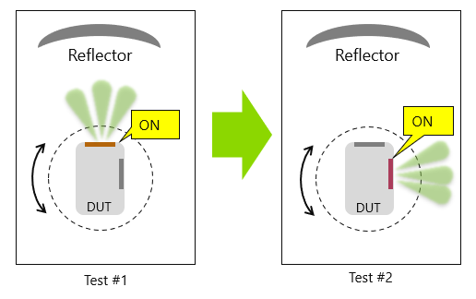

Figure 5.2.6-1: Example measurement setup (Method 1) with test mode to fix active antenna.

The second approach (Method 2) is illustrated in Figure 5.2.6-1 and based on the following high-level procedure:

- Perform Rx Beam peak search for *AoA1*.

- Connect the SS (System Simulator) with the DUT through the measurement antenna to form the RX beam towards the RX beam peak direction and respective polarization found for *AoA1*.

- SS activates the UE Beamlock Function (UBF) on *AoA1*. If necessary, switch the connection of the SS from the measurement antenna to the link antenna.

- Perform Rx Beam peak search for *AoA2*.

The idea behind this approach is to augment/modify the existing UE Beamlock Function (UBF), i.e., lock a beam connected to one receiver while a second connection is still possible with freedom on the direction and/or panel used.

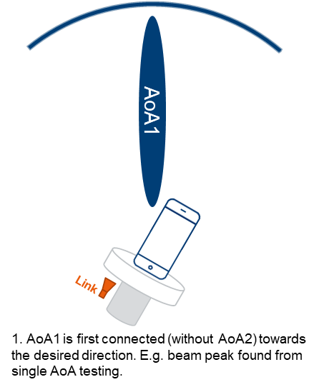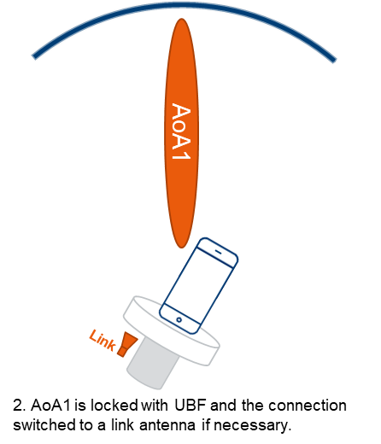

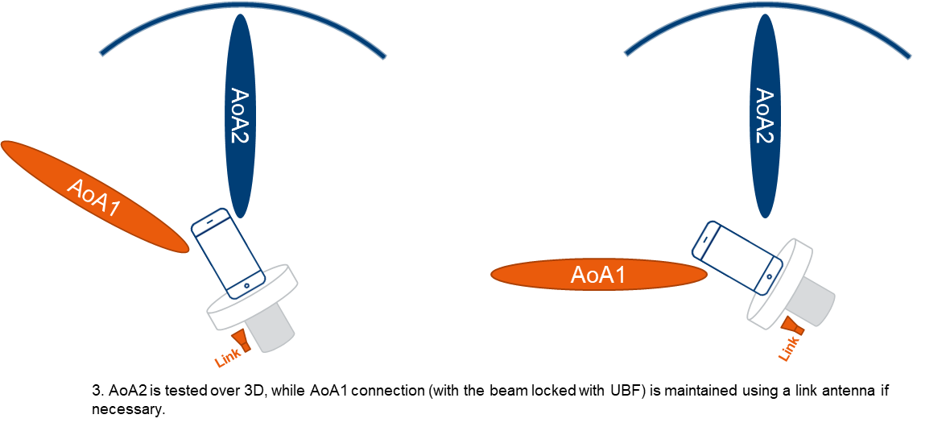

Figure 5.2.6-2: Example measurement setup (Method 2) with augmented UBF test mode.

Method 1 cannot verify the potential cross talk between two AoAs especially then the two AoAs are with a small angular separation. When performing sequential tests, the testing is not verifying the real performance of multi-Rx UEs. Method 2 does not suffer from these issues, but it was not concluded whether the measurements on the locked beam (i.e. AoA1 in Figure 5.2.6-2) may be impacted by the link antenna in the Near Field.

### 5.2.7 Measurement Setup to reduce sensitivity to UE orientation in holder with full degrees of freedom for AoA1 with fixed angular offset(s) between AoA1 and AoA2

#### 5.2.7.1 Background and Motivation

The system described in 5.2.2 has strong continuity with legacy systems, and therefore warrants further development. The system has reduced flexibility in placing source locations due to a fixed relative location of the sources. If this arrangement is used with a legacy 2 axis positioner, the UE can only be tested with some subset of all possible AoA pairs for a given AoA separation or offset. See Figure 5.2.7.1-1 for a graphical representation of the set of all possible testable AoA pairs by the system described in 5.2.2 in conjunction with a 2-axis positioner and a constant step-size scan. The restriction of the AoA pairings strictly towards one pole or the other can influence the measured 2AoA reception performance of the UE as a function of its orientation in the positioner during test.

*Red dots are grid point locations*

*For each grid point location, the companion AoA associated with the other TRP is along the direction indicated by the blue segments for the legacy 2-axis positioner.*

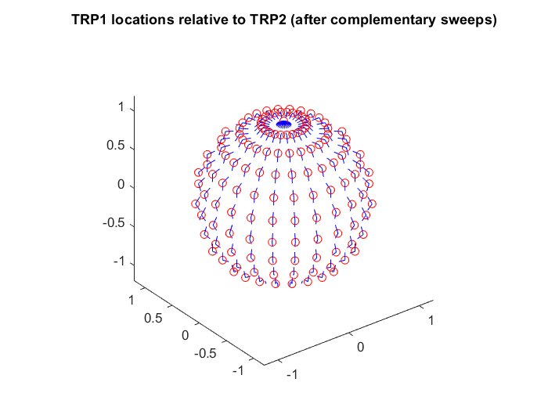

Figure 5.2.7.1-1: From the UE’s perspective, AoA pairs lie along meridians of a spherical coordinate system for a test system with fixed offset between the sources and a 2-axis positioner.

Conceptually, robustness to orientation can be accomplished by adding test AoAs uniformly distributed on the sphere in more directions rather than just along the meridians. This necessitates using a 3-axis positioner in the agreed TE system rather than the legacy 2-axis positioner. Figure 5.2.7.1-2 graphically shows the intended goal of the added degree of freedom from the UE’s perspective.

v

*The intent is to sample the outcomes in spatially uniform directions to reduce bias.*

*The orange circle represents the set of all AoAs that are separated from the any grid location by some fixed AoA separation.*

Figure 5.2.7.1-2: Scheme to combat bias introduced by AoA pairs limited to lie along meridians from the UE’s perspective.

Recall that the legacy 2-axis positioner is only able to pair each grid point to AoAs along the blue arrows, respectively (see Figure 5.2.7.1-1). The 3-axis positioner is intended to allow each grid point to be additionally paired with AoAs along the green arrows. These additional directions essentially dismantle the restriction of having test AoA pairs exclusively along meridians of a spherical coordinate system from the UE’s perspective.

Simulated test runs with a UE with modules on adjacent confirms the intended enhancement removes sensitivity to UE orientation, see Figure 5.2.7.1-3. ‘D’ referenced in the figures is used in the sense of degree of freedom of the positioner, rather than spatial dimension. HH or VV refer to beam scanning directions for both modules, each assumed to be 4x1.

Positioner upgrade from 2-axis to 3-axis

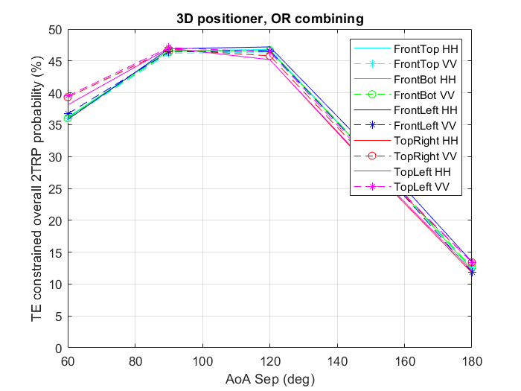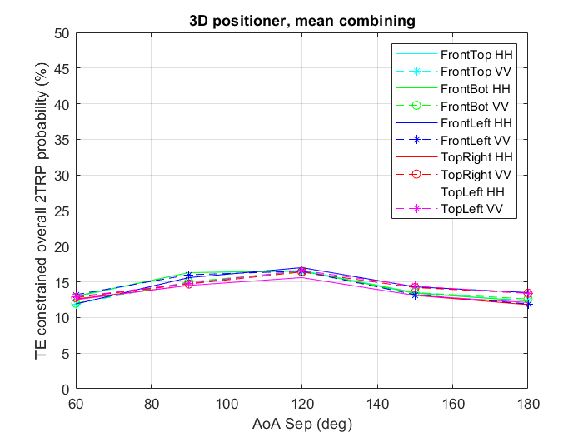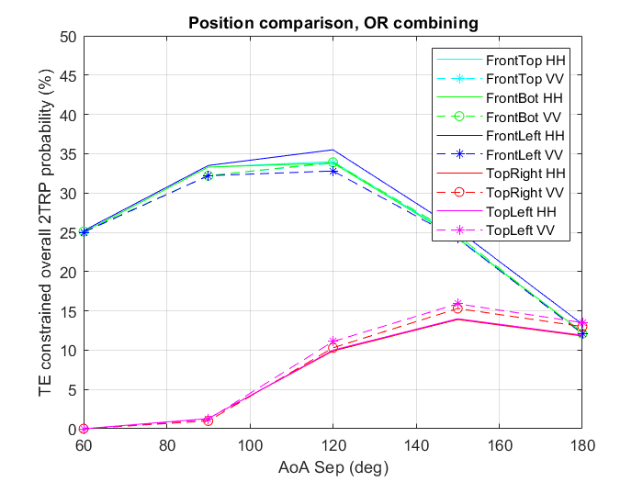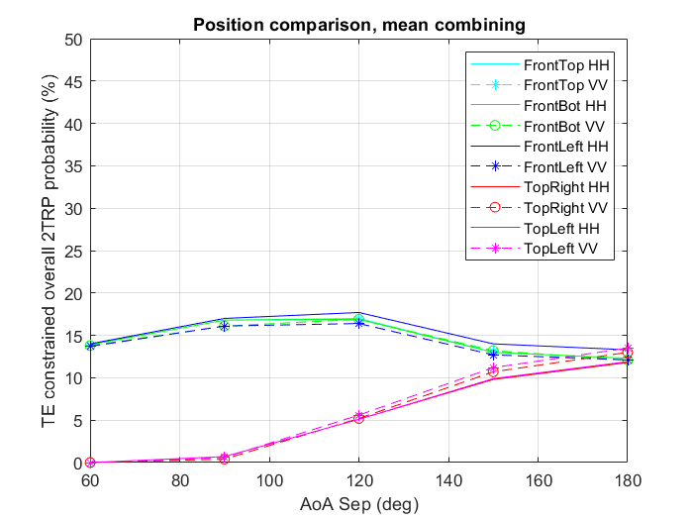

Orientation sensitivity from using a legacy 2-axis positioner.

Figure 5.2.7.1-3: UE orientation sensitivity removal using a 3-axis positioner.

#### 5.2.7.2 Implementation Direction

The basic idea to implement this type of 3-axis positioner is an ‘inside’ 2-axis positioner that has similar functionality to the legacy positioner mounted to a fixed ‘outside’ roll-motor (‘outside’ to indicate it is not part of the positioner that would implement the basic scan). The ‘inside’ 2-axis positioner could be implemented as a azimuth-roll set-up (legacy geometry), an elevation-azimuth type positioner or other equivalent type. The ‘fixed’ aspect of the outside roll-motor refers to the fact that its stator would be statically positioned relative to the source locations, with its shaft axis pointed at one of the sources. This target source’s AoAs define the grid where the UE’s performance is evaluated. Figure 5.2.7.2-1 helps visualize the AoA pairings at each grid point.

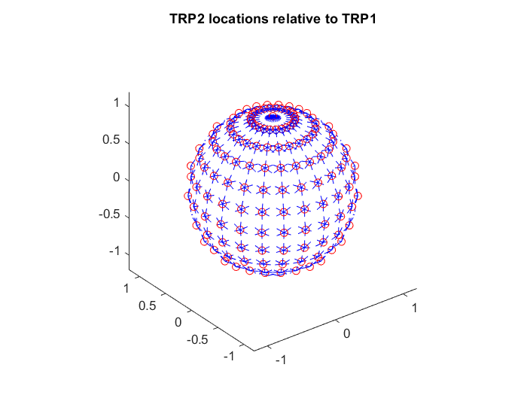

*Red dots are grid point locations where the regional probability is calculated.*

*For each grid point location, a configurable number of AoA pairs is possible with a 3-axis positioner. Example shown with 6 pairs (blue segments indicate directions of test AoA pairs, second source locations suppressed for simplicity)*

Figure 5.2.7.2-1: Visualization of AoA pairs associated with each point with the proposed 3-axis positioner

One helpful aspect is that the 3-axis positioner no longer needs 180⁰ swing of the azimuth motion from the ‘inside’ 2-axis positioner for each scanned hemisphere: It is possible for the inside positioner to use a 90⁰ azimuth, 360⁰ roll strategy if advantageous.

Figure 5.2.7.2-2 helps with conceptual description of how the third degree of freedom in the positioner can be leveraged to achieve the grid and AoA pairings of 5.2.7.2-1. The blue and the green shafts represent the ‘inside’ 2-axis positioner, and they are together mounted on the outside roll motor shaft (red items). Two options are shown for the implementation of the ‘inside’ 2-axis positioner: azimuth-elevation and azimuth-roll. The latter option allows continuity with the legacy positioner grid and geometry. Detail design work is needed to adequately hide the motors to reduce the prospect of blockage, as well as other details like bringing the articulation axes closer; these are up to TE implementation. In either implementation the ‘outside’ roll motor is ground referenced like the sources and points to one of them, say S1 (grey body in the figures below).

‘Outside’ roll motor axis is fixed towards one of the sources. It is actuated for multiple AoA pairs at same grid point.

‘inside’ 2-axis positioner mounted to roll motor, implemented as azimuth-elevation.

Towards one of the sources ‘S1’ at P0

*Objects are color-coded to indicate rigid inter- connection.*



‘inside’ 2-axis positioner mounted to roll motor, implemented as azimuth-roll.

Towards one of the sources ‘S1’ at P0

Figure 5.2.7.2-2: Bias reducing 3-axis positioner concepts.

The sequence of actuation can be considered equivalent to the following:

- Step 1: The outside roll motor starts off at the zero-rotation location (as shown) and the ‘inside’ 2-axis positioner (blue and green axes) mounted to the roll motor is used to move S1 to the desired grid point from the UE’s perspective.

- Step 2: The outside roll-motor is then actuated over 360⁰ with an arbitrary number of stops for measurement. Each stop represents an AoA pair with one source (S1) fixed in space

- Step 3: Once the outside roll-motor returns to the zero position, the ‘inside’ 2-axis positioner is used to move S1 to the next grid point

- Step 4: (Loop to step 2 until S1 is moved through all grid points).

More realistic views of the positioner are shown in Figure 5.2.7.2-3.

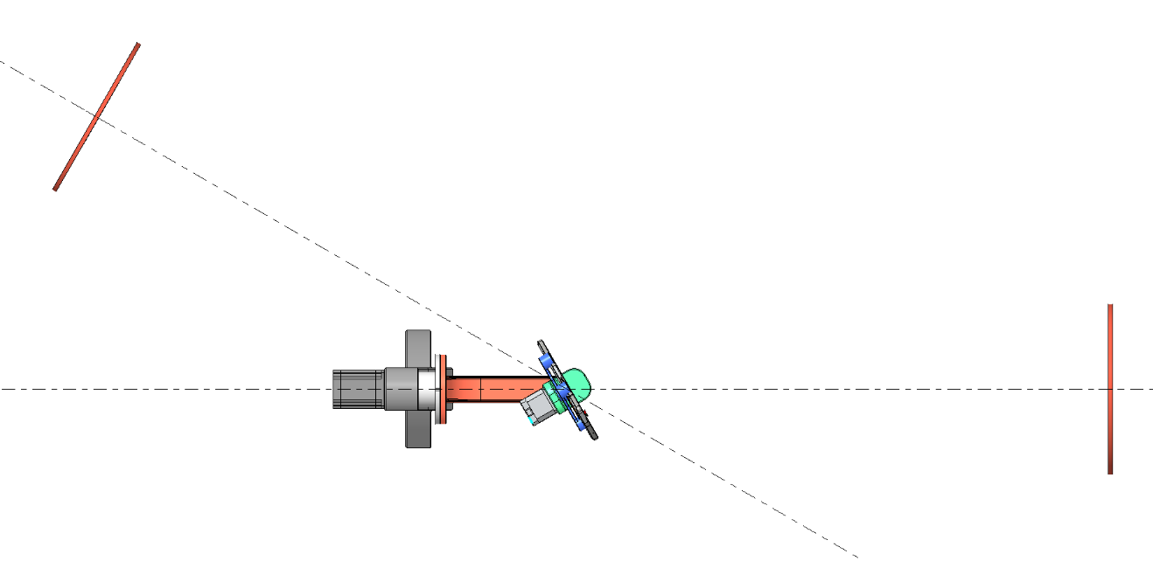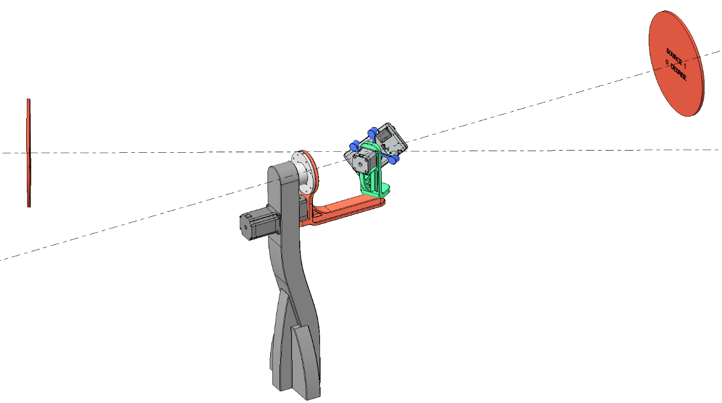

‘Outside’ roll motor

‘Outside’ roll motor axis is fixed towards S1.

Inside AZ: 30˚

Inside Roll: 45 ˚

Outside Roll: 0˚

S1

S2

Roll motor of ‘Inside’ 2-axis positioner

Az hinge of ‘Inside’ 2-axis positioner

S1

S2

S2

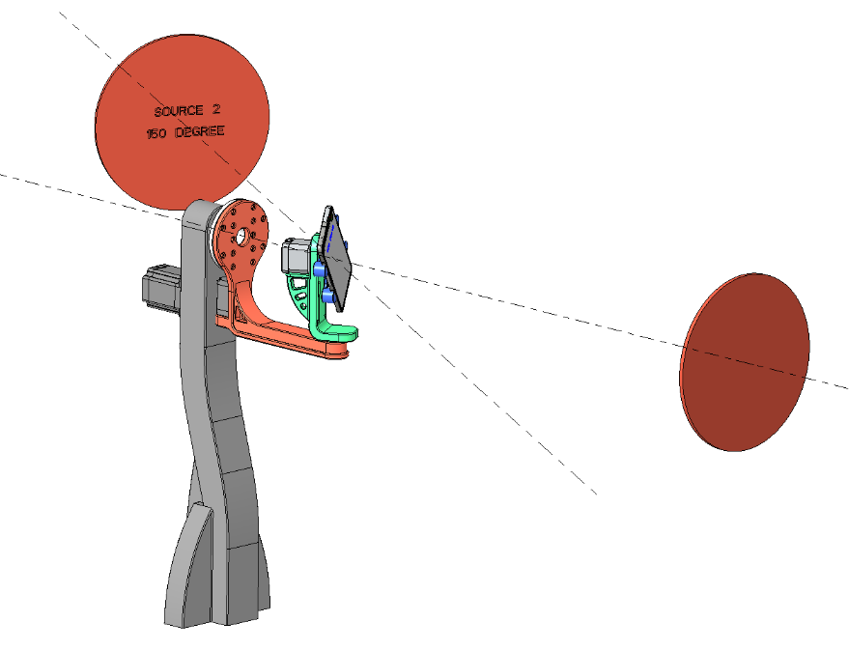

Figure 5.2.7.2-3: More realistic depiction of an example implementation of the 3-axis positioner.

#### 5.2.7.3 Scan strategy to avoid source blocking

The focus in this section is on an outside-roll-azimuth-roll positioner implementation, due to continuity of grid geometry with legacy positioners. Blocking is an important consideration for 2TRP connectivity. With the agreed TE with the legacy 2-axis positioner, both sources must be confined to a 180⁰ sector in the horizontal plane, to stay out of the 180⁰ swing of the azimuth motion of the positioner. With the proposed 3-axis positioner however, the roll axis of the outside motor is fixed to point to one of the sources, and the system loses its rotational symmetry. This means that the new positioner mechanism cannot be equally hidden from both sources for all AoA separations like the strategy used with the legacy positioner. There are two types of source blockages to navigate:

1. Source blockage due to inside positioner mechanics.

2. Source blockage due to outside roll-motor arm to which the inside positioner is mounted.

The blocking situation is more realistically depicted in Figure 5.2.7.3-1 in the form of a sequence of typical outside roll motor actuation. Note that azimuth and source separation sum up to 180⁰, a relationship that is identified as the main condition for blocking to occur. This configuration depicts instances of both types of blockage. The red dotted highlight shows S2 blockage due to the inside positioner, while the blue dotted highlight shows S2 blockage due to the arm mounted to the outside motor.

Outside Roll: 0˚

Outside Roll: 60˚

Outside Roll: 120˚

Outside Roll: 180˚

Outside Roll: 240˚

Outside Roll: 300˚

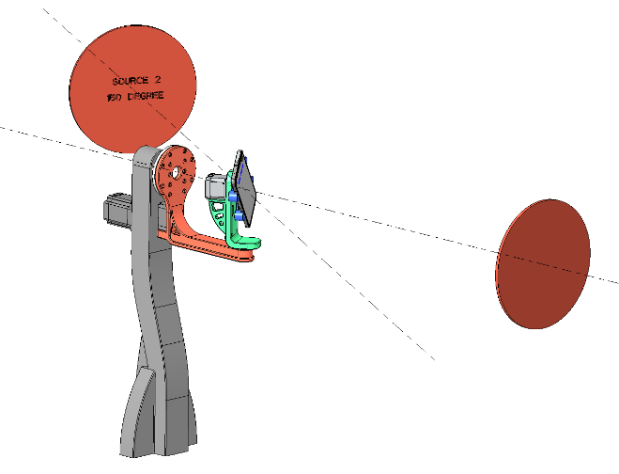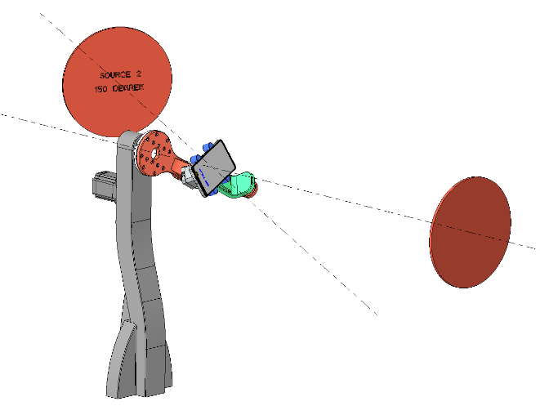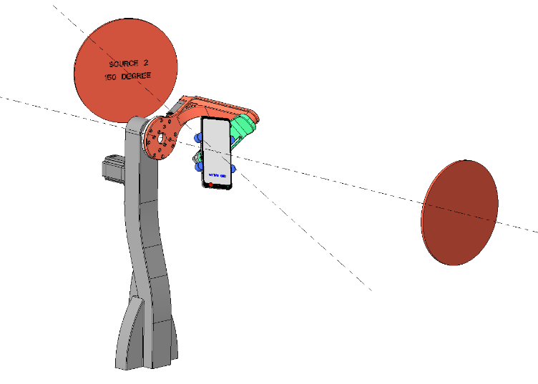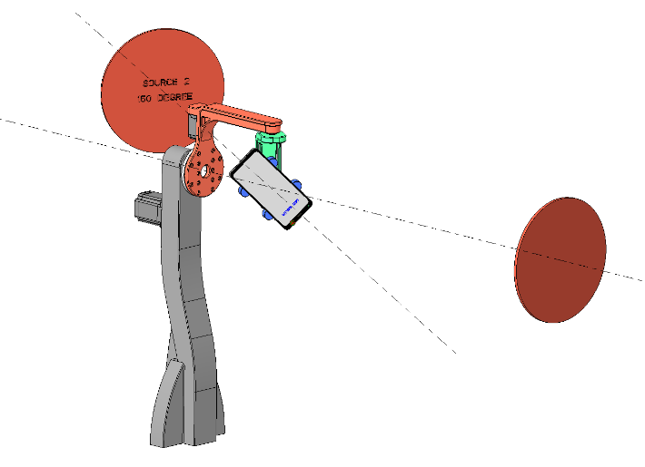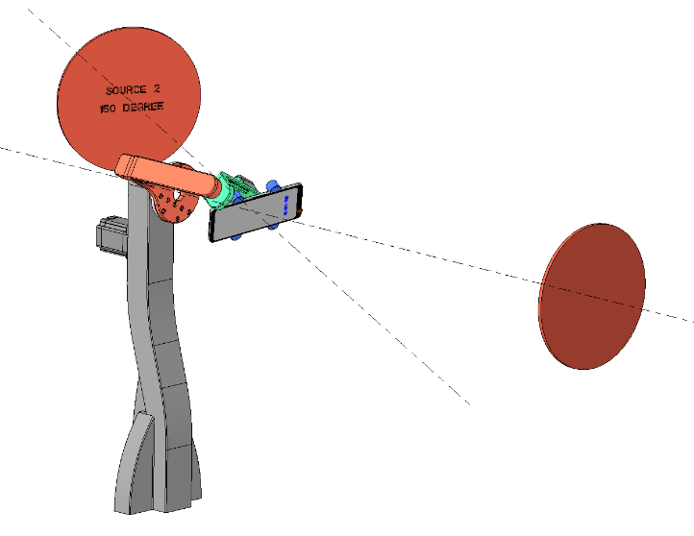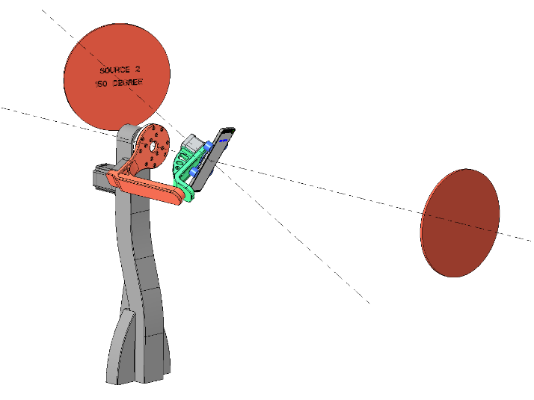

Blockage due to inside positioner

Blockage due to outside motor arm

Figure 5.2.7.3-1: Blockage issue with 3-axis positioner, viewed from azimuth axis.

Blockage due to the insider positioner:

Even if the reduced azimuth motion (per hemisphere) of the inside 2-axis positioner is reduced to [0-90⁰], the outside roll motor would swing the ‘inside’ positioner into the LOS of the second source for source separations of 90⁰ or more. Conceptually, the blockage occurs when the second source (S2) approaches the pole of the grid where the inside positioner is located. This blockage condition is not due to the choice of positioner, but instead due to the choice to test each point with AoA pairs in more directions than just along meridians.

This situation manifests for all grid points whose theta coordinate approaches the supplementary angle (180-x) to the source separation angle. Furthermore, blocking may only occur for some subset of outside-motor roll angles. See Figure 5.2.7.3-2. For perspective, it is useful to remember that this blockage condition is not due to the choice of positioner, but instead due to the choice to test each point with AoA pairs in more directions.

South pole

External roll motor axis

UE

S1

Effective locus of S2 as external roll motor is actuated.

Example S2 locations where UE 2TRP functionality is verified.

Outside-motor roll angles that cause S2 blockage.

S2

Inside positioner shown pointing the UE to some grid point.

Figure 5.2.7.3-2: Blockage issue due to inside positioner of a 3-axis positioner, viewed from (the inside) azimuth axis of the example implementation.

The fraction of AoA pairs where one source is near the south pole is relatively small and can be identified a-priori for each hemisphere scan and re-assigned to the opposite hemisphere scan. For the opposite hemisphere scan, the second source would flip over to near the north pole and the first source would also flip but it will remain clear of the south pole, provided AoA separation is not 180⁰. So, a blocked AoA in one hemisphere scan is not blocked during the opposite hemisphere scan. Another detail is that for the blocked AoA pairs, the second source location is now the one near the north pole (originally designated S1). It may not fall on the originally chosen grid, but that should not matter to the ‘inside’ positioner. The external roll motor can then position the flipped first source (originally designated S2) at the desired location in the southern hemisphere. Since the AoA pair reorganization can be done a-priori, there is no foreseen test time impact.

To summarize, a ‘no-block’ strategy to dodge the inside positioner can be implemented by exchanging some pre-identified test AoAs across the two hemisphere scans. Since the blocked region is essentially due to the mechanical outline of the inside positioner, it is up to TE implementation to treat the considerations presented below:

1. Various motion transfer schemes can be leveraged to reduce the shadow region, which reduces the number of AoA pairs that may be blocked.

2. It would be mathematically consistent to re-orient the sample points on the circle (locus of second source during the outside motor roll) to reduce blockage. i.e., move all stops for the external roll motor for that grid point by some convenient angle to avoid the shadow region.

Blockage due to outside positioner arm:

As the outside motor’s is stepped at any grid point, some stops will cause the mechanics carrying the inside positioner to block the source. The strategy is to leverage multiple different mechanical configurations to achieve the same UE pointing direction relative to the two sources. An example is shown below for a given UE pointing direction.

|  |  |  |
| --- | --- | --- |
| TE coordinates | Option 1 | Option 2 |
| Outside roll (deg) | α | α + 180⁰ |
| Inside azimuth (deg) | β | -β |
| Inside roll (deg) | γ | γ + 180⁰ |

Since the same orientation is achieved with two different outside roll settings, the TE retains a way to dodge a blockage condition induced by the outside motor angular position. The following views of the system in a configuration that demonstrate the blocking issue endemic to testing each point with at least 3 equally spatially distributed AoA pairs. Sources are shown as flat discs. Source separation angle is 150⁰. Chosen grid point for illustration is S1 at theta=30⁰, phi = -45⁰. Note that azimuth and source separation sum up to 180⁰, a relationship that is identified as the main condition for blocking to occur. Geometries are not optimized for blockage reduction.

The highlighted view is an example of how the outside motor arm can impede line of sight between the UE and source S2. In the illustration below, an alternative set of coordinates achieve the same UE orientation relative to the sources, but the arm is no longer in a blocking location. This strategy is an example of a no-block strategy for the outside motor. Figure 5.2.7.3-3 shows the strategy to allow the outside motor to dodge the line of sight to source S2 for the example 3-axis implementation. On the right is the blocking condition, note orange arm is in line of sight to source S2. On the left is an equivalent UE pointing direction but without blockage from the outside motor arm.

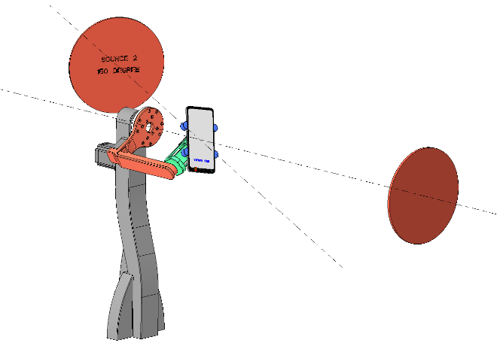

Internal AZ: -30˚

Internal Roll: 225˚

External Roll: 300˚

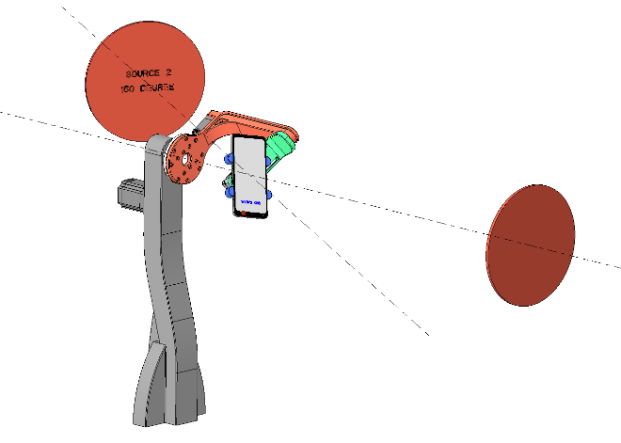

Internal AZ: 30˚

Internal Roll: 45˚

External Roll: 120˚

Figure 5.2.7.3-3: No-block strategy for outside motor arm the example implementation of a 3-axis positioner.

To summarize, a ‘no-block’ strategy to dodge the outside arm can be implemented by taking advantage of the fact that there are multiple unique positioner settings to achieve the same UE pointing direction.

#### 5.2.7.4 Pros and Cons

Table 5.2.7.4-1: Overview of positioner enhancement

|  |  |
| --- | --- |
| Description | Full degrees of freedom for AoA1 with fixed angular offset(s) between AoA1 and AoA2 |
| Probe Offset Option | Fixed Angular Offset(s) between AoA1 and AoA2 in the chamber. The angular separation between AoA1 and AoA2 is NOT changing during the testing |
| Positioner | 3-axis such that AoA pairs at each grid point are not strictly limited to poles of the spherical coordinate system in the UE’s perspective |
| Pros | - Removes sensitivity to UE orientation by enabling test AoA pairs for any separation that are not limited by some geometric constraint.  - Enhanced positioner enables full backward compatibility with legacy requirements and techniques  - Small chamber footprint/chamber heights  - Multiple AoA1/AoA2 combinations can be tested  - A wide range of angular difference between AoA1 and AoA2 can readily be tested |
| Cons | - System complexity high, due to 3-axis positioner  - Existing systems cannot be retrofit easily  - MU may have to revisited  - Blockage-dodging strategy is a stronger function of TE implementation than with the 2-axis positioner case |

## 5.3 Test System Aspects

### 5.3.1 Absolute Probe Locations

A sample system with three different probe locations as shown in Figure 5.3.1-1 is investigated to provide detailed justification to define absolute probe locations/directions for Multi-AoA UE RF testing. The sample implementation has a 2-axis positioning system for the DUT to implement a 3D scan and three probes in the *x*, *y*, and *z* axes with the assumption that AoA1 is along *z* and AoA2 along *x* or *y*. The DL directions perceived by the DUT from each probe are illustrated with red, green, and red spheres on the DUT grid in the *x*, *y*, and *z* directions, respectively, for this initial test point of (q, f) = (0°, 0°).

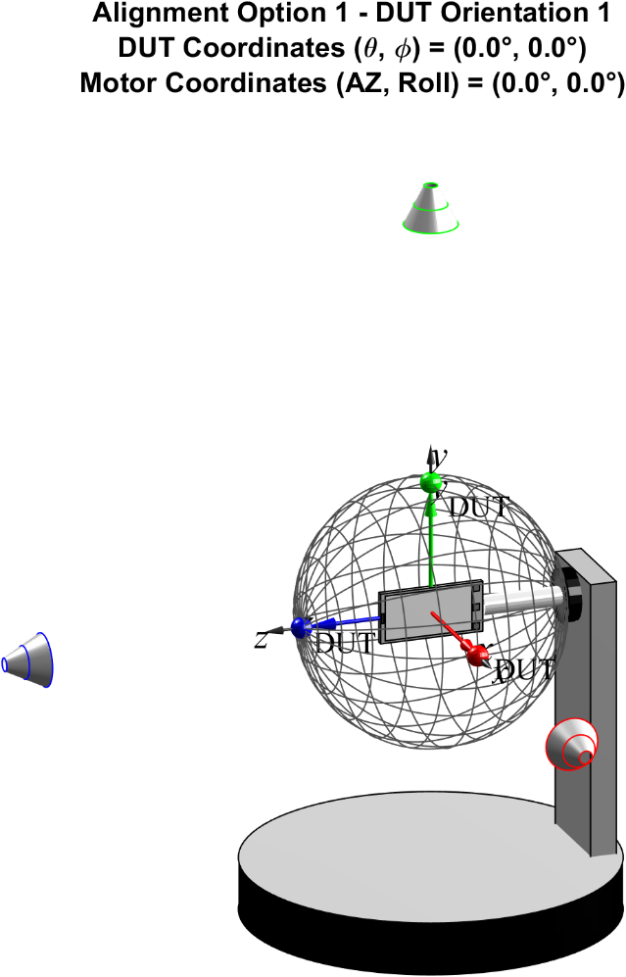

Figure 5.3.1-1: Sample measurement setup with three fixed probe locations for initial test point of (0°, 0°)

For the sample multi-AoA system investigated, the angular difference between AoA1 (*z* direction) and AoA2 (*x* direction) and between AoA1 (*z* direction) and AoA2 (*y* direction) is 90° in both cases. One could seemingly argue that the roll motor of the DUT (rotation around the DUT *z* axis) makes it irrelevant whether AoA2 is along the *y* or the *x* axis. However, once the device is rotated in 3D, i.e., q and f, this argument is no longer applicable which is further analysed and illustrated below. For a second sample device orientation of (q, f) = (45°, -45°), the perceived DL directions are illustrated on the rotated DUT grid in Figure 5.3.1-2. Clearly, a 90° rotation of the device around its *z* axis would no longer map the green sphere onto the red sphere.

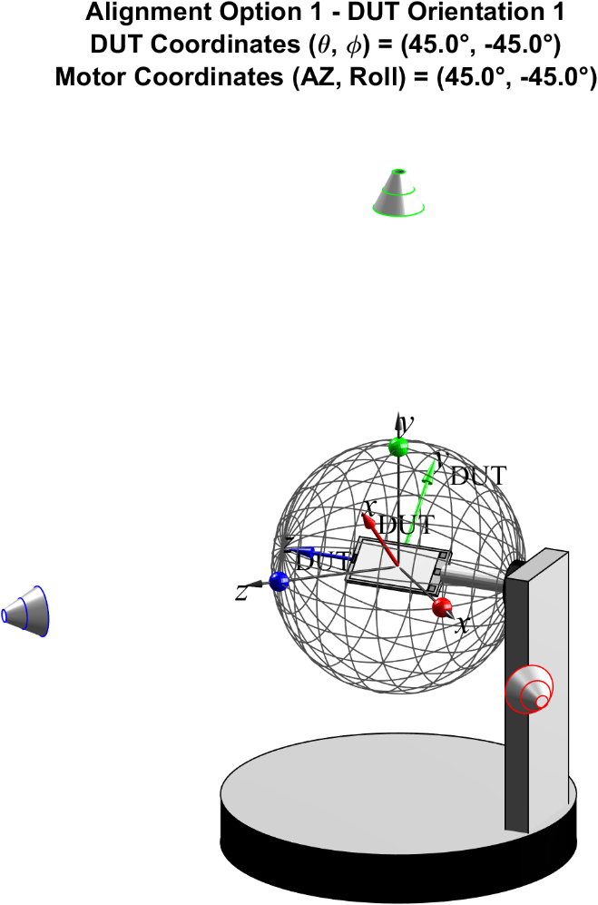

Figure 5.3.1-2: Sample measurement setup with three fixed probe locations for test point of (45°, -45°)

It is now assumed that the test points in 3D are based on a constant-step size grid with 266 unique grid points (Dq=Df=15°), i.e., as defined for PC1 & PC3 spherical coverage test cases for 1-DL in Clause 5.3 of [6], or on a constant density grid with 200 unique grid points, i.e., as defined for PC1 spherical coverage test cases for 1-DL in Clause 5.3 of [6]. These test/grid points are visualized in Table 5.3.1-1.

Table 5.3.1-1: Visualization of spherical coverage test/grid points

|  |  |
| --- | --- |
| Constant-step size grid with 266 unique grid points (Dq=Df=15°) | Constant density grid with 200 unique grid points |
|  |  |

When all spherical coverage grid points are sampled with 0°≤q≤180° and 0°≤f≤360°, the DL directions perceived by the UE from the various probes are plotted in Table 5.3.1-2. Clearly, these results show vastly different results.

- For the probe aligned with the *z* axis, the perceived DL directions match the test points.

- For the probe aligned with the y axis, the DUT only perceives the DL in a single plane only, i.e., the DUT’s xy plane. This is due to the turntable axis of the OTA positioner aligned with the y axis, i.e., the turntable rotation merely changes the polarization but not the DL direction with this probe. The roll motor, i.e., the rotation of the DUT around its z axis, only adjusts the DL direction within the xy plane.

- For the AoA2 probe aligned with the *x* axis, the DL directions are perceived from different directions in (q, f) but limited to a single hemisphere only.

The plots of the perceived DL directions from different, fixed probes demonstrate the need to define the absolute probe locations/directions for UE RF systems so that different test systems yield the same results.

Table 5.3.1-2: DL directions perceived by the DUT from probes in the *x*, *y*, and *z* axes.

|  |  |  |
| --- | --- | --- |
| Probe Along Direction | DL Directions perceived by DUT with constant-step size grid with 266 unique grid points (Dq=Df=15°) | DL Directions perceived by DUT with constant density grid with 200 unique grid points |
| *z* |  |  |
| *y* |  |  |
| *x* |  |  |

### 5.3.2 Minimum and Maximum Angular Separation between Probes

Due to the finite size of the probes, the minimum angular separation between probes will be limited to prevent collisions and thus prevent a “full” degree of rotation freedom of one AoA unless probes are placed back-to-back as illustrated in Figure 5.2.3-3 which on the other hand introduces blocking effects.

The minimum angular separation between neighbouring reflectors is larger than the minimum separation between two regular millimetre-wave probes as illustrated in Figure 5.3.2-1. It is estimated that the minimum angular separation between two IFF probes is about 30° while the minimum angular separation between two DFF probes is about 5°.

Although DFF is one of the permitted methodologies for FR2 OTA testing [10], IFF is the de-facto reference methodology for FR2 OTA measurements. To enable the applicability of IFF to multi-AoA UE RF testing [3, 12], the largest minimum angular separation of DFF and IFF must be selected, i.e., the minimum angular separation between probes must be 30°.



Figure 5.3.2-1: Illustration of minimum angular separations between IFF (top) and DFF probes.

The maximum angular separation between probes could be as large as 180°. However, this angular separation would result in significant blocking between one AoA probe and the DUT positioner, as illustrated in Figure 5.3.2-2, and the line-of-sight path between both probes also introduce a significant amount of coupling. It was therefore suggested to limit the maximum angular separation between probes/AoAs to 150° (blue reflector/probe in Figure 5.3.2-2).



Figure 5.3.2-2: Illustration of maximum proposed angular separation including blocking for angular separation of 180°.

Additionally, placing two reflectors opposite to each other will yield higher variations in field/power measurements within the QZ caused by reflections from one reflector facing another head on. As illustrated in Figure 5.3.2-3, the two dark grey reflectors with 180° separation illuminate each other with plane waves, i.e., without much attenuation; scattering from the metal surfaces including edges of the reflector will thus reflect energy back towards the source probe. On the other hand, the cross coupling between the reflector at 0° and the red or blue reflectors is minimized as they are not in each other’s direct path. It was argued that the cross coupling between the two opposing reflectors should be insignificant given the large separation and thus large path losses. However, the reflectors are in each other’s collimated beam’s path, i.e., signal from the right reflector arriving at the left reflector should not have experienced much of an attenuation when compared to the signal at the QZ.

It should furthermore be highlighted that 2 AoA RRM systems currently limit the maximum separation between probes to 150° [12], specifically Table A.3.15.3-1.

Requiring a 180° separation for multi-AoA Rx testing would therefore not allow a re-use of existing 2 AoA RRM systems as they would not be able to support the larger separation.



Figure 5.3.2-3: Illustration of maximum proposed angular separation including blocking for angular separation of 180°.

### 5.3.3 Impact of Probe Locations and 3D Scans on DL Directions

A full 3D scan, typically required for beam peak searches, spherical coverage test cases and TRP measurements, can be performed in various ways as illustrated in Table 5.3.3-1. Here, a single-probe, combined-axes OTA system with the probe aligned in the *z* direction is shown with two different methodologies to achieve a full 3D UE rotation/scan:

- full rotation in f (around *z* axis) and half rotation in q (around *y* axis) as shown in left column

- full rotation in q (around *y* axis) and half rotation in f (around *z* axis) as shown in right column

As shown in the table for the constant-step size grid with 312 grid points (Dq=Df=15°, 266 of which are unique due to the redundant points at the poles) on top or the constant-density grid with 200 grid points on the bottom, either approach will yield the same test point coverage.

Table 5.3.3-1: 3D scan implementations and resulting coverage using single-probe system

|  |  |  |
| --- | --- | --- |
|  | Single-probe system configuration with 3D scan using full rotation in f and half rotation in q | Single-probe system configuration with 3D scan using full rotation in q and half rotation in f |
| System Configuration |  |  |
| Constant-Step Size Grid with 312 grid points (Dq=Df=15°); 266 unique grid points |  | |
| Constant Density Grid with 200 grid points |  | |

It was agreed to define absolute probe locations as different 2D planes containing the various AoA probes were shown to have vastly different effects on the perceived DL directions by the UE, see Clause 5.3.1. For simplicity, sample test systems with just 4 total probes (1 AoA1 probe and 3 AoA2 probes) are considered next. Here, the AoA2 probes are displaced by 60° (P60), 120° (P120), and 150° (P150) from the AoA1 probe placed along the *z* direction (P0). As illustrated in Table 5.3.3-2, one system configuration has the AoA2 probes aligned in the *xz* plane (left), and another system configuration has the AoA2 probes aligned in the *yz* plane (right). Aside from studying the effect of different probe locations on the perceived DL directions, the two different 3D approaches are investigated as well, i.e., by rotating the device a full turn in f (rotation axis *z*) and a half turn in q (rotation axis *y*) as shown the top of Table 5.3.3-2 and alternatively, a full turn in q (rotation axis *y*) and a half turn in f (rotation axis *z*) as shown the bottom of Table 5.3.3-2.

The following analyses for constant step-size grids take into account that multiple measurements at the pole for P0 are performed; while these measurements yield unique DL directions for P0, they translate to non-unique DL directions for P60, P120, and P150.

Table 5.3.3-2: System configurations with probes in the *xz* plane (left) and *yz* plane (right). 3D scan performed with full rotation in f and half rotation in q (top) and with full rotation in q and half rotation in f (bottom)

|  |  |  |
| --- | --- | --- |
|  | Probes in the *xz* plane | Probes in the *yz* plane |
| 3D Scan: full rotation in f and half rotation in q |  |  |
| 3D Scan: full rotation in q and half rotation in f |  |  |

The system configurations with full rotation in  and half rotation in  and the perceived DL directions are further illustrated in Table 5.3.3-3 for a constant-step size grid with 312 grid points and in Table 5.3.3-4 for a constant density grid with 200 grid points. Similarly, the system configurations with full rotation in q and half rotation in f and the perceived DL directions are further illustrated in Table 5.3.3-5 for a constant-step size grid with 312 grid points and in Table 5.3.3-6 for a constant density grid with 200 grid points. The following observations can be made from these results:

- Probes aligned in the *yz* plane introduce large keep-out areas for the angular coverage/DL directions towards each pole.

- With full rotation in f and half rotation in q, probes aligned in the *xz* plane introduce a conical sector towards the pole at q=0° with no angular coverage/DL directions for offset probes.

- Constant density grids do not maintain the constant density coverage/DL direction distribution for probes offset from P0, a higher density of DL directions is observed especially near the poles.

- When probes are aligned in the *xz* plane, constant-step size grids maintain the constant-step size distribution of DL directions for probes offset from P0.

- Probes aligned in the *xz* plane generally provide a wider angular coverage for AoA2 DL directions when compared to probes aligned in the *yz* plane.

- With full rotation in q and half rotation in f and probes aligned in the *xz* plane, the AoA2 DL directions are distributed in 3D without a conical region with lack of coverage.

- Only with full rotation in q and half rotation in f, probes aligned in the *xz* plane, and constant-step size grids, uniform angular coverage/DL directions is achieved, i.e., the distribution of DL directions for all probes on the *xz* plane match the distribution of grid points.

Based on the observations made in this section, the following decisions were made:

- For optimized AoA1 and AoA2 test point/perceived DL direction coverage, apply a full rotation in  and a half rotation in .

- For optimized AoA1 and AoA2 test point/perceived DL direction coverage, utilize constant-step size grids only.

- For optimized AoA1 and AoA2 test point/perceived DL direction coverage, place the AoA2 probes in the *xz* plane

Table 5.3.3-3: DL directions perceived by the DUT from two different system configurations with AoA2 to AoA1 probe offsets of 60°, 120°, and 150° with a constant-step size grid using 312 grid points (Dq=Df=15°). Full rotation in f and half rotation in q.

|  |  |  |
| --- | --- | --- |
|  | Probes in the *xz* plane | Probes in the *yz* plane |
| System Configuration with full rotation in f and half rotation in q |  |  |
| DL Directions perceived by DUT from Probe P60 |  |  |
| DL Directions perceived by DUT from Probe P120 |  |  |
| DL Directions perceived by DUT from Probe P150 |  |  |

Table 5.3.3-4: DL directions perceived by the DUT from two different system configurations with AoA2 to AoA1 probe offsets of 60°, 120°, and 150° with a constant density grid using 200 grid points. Full rotation in f and half rotation in q. Full rotation in f and half rotation in q.

|  |  |  |
| --- | --- | --- |
|  | Probes in the *xz* plane | Probes in the *yz* plane |
| System Configuration with full rotation in f and half rotation in q |  |  |
| DL Directions perceived by DUT from Probe P60 |  |  |
| DL Directions perceived by DUT from Probe P120 |  |  |
| DL Directions perceived by DUT from Probe P150 |  |  |

Table 5.3.3-5: DL directions perceived by the DUT from two different system configurations with AoA2 to AoA1 probe offsets of 60°, 120°, and 150° with a constant-step size grid using 312 grid points (Dq=Df=15°). Full rotation in q and half rotation in f.

|  |  |  |
| --- | --- | --- |
|  | Probes in the *xz* plane | Probes in the *yz* plane |
| System Configuration with full rotation in q and half rotation in f | s |  |
| DL Directions perceived by DUT from Probe P60 |  |  |
| DL Directions perceived by DUT from Probe P120 |  |  |
| DL Directions perceived by DUT from Probe P150 |  |  |

Table 5.3.3-6: DL directions perceived by the DUT from two different system configurations with AoA2 to AoA1 probe offsets of 60°, 120°, and 150° with a constant density grid using 200 grid points. Full rotation in q and half rotation in f.

|  |  |  |
| --- | --- | --- |
|  | Probes in the *xz* plane | Probes in the *yz* plane |
| System Configuration with full rotation in q and half rotation in f |  |  |
| DL Directions perceived by DUT from Probe P60 |  |  |
| DL Directions perceived by DUT from Probe P120 |  |  |
| DL Directions perceived by DUT from Probe P150 |  |  |

### 5.3.4 DL Polarizations Perceived by the UE

The DL polarizations perceived by the UE from various probes placed in different locations and 2D planes is investigated in this Annex. For better visualization purposes, a coarse measurement grid with 84 grid points for the constant-step size grid (Dq=Df=30°) and 50 grid points for the constant density grid is considered.

The DL directions and polarizations perceived by the DUT for a sample system with the AoA1 probe in the *z* direction and AoA2 probes in the *x* and *y* directions are presented in Table 5.3.4-1 for just the constant-step size grid. The magenta arrows demonstrate the q polarization while the orange arrows demonstrate the f polarization with respect to the probe antenna/system coordinate system. Clearly, for the probes placed in the *z* and *x* directions, the DL polarizations w.r.t. the DUT coordinate system are preserved, i.e., the probe antenna DL q/f polarization matches the DUT q/f polarization. However, for the probe along the *y* axis, the DL polarization perceived by the DUT changes depending on grid point. Similar observations can be made for a system configuration with multiple AoA2 probes placed on the *xz* and the *yz* planes. The system configurations with full rotation in  and half rotation in  and the perceived DL directions are further illustrated in Table 5.3.4-2 for the constant-step size grid and in Table 5.3.4-3 for the constant density grid. Similarly, the system configurations with full rotation in q and half rotation in f and the perceived DL directions are further illustrated in Table 5.3.4-4 for the constant-step size grid and in Table 5.3.4-5 for the constant density grid.

These results again show that the probe antenna DL q/f-polarizations from AoA2 probes (w.r.t. the system coordinate system) are preserved only when the AoA2 probes are placed in the *xz* plane, i.e., antenna DL q/f polarizations map to DUT q/f polarizations, while this is no longer the case for AoA2 probes are placed in the *yz* plane, i.e., probe antenna DL q/f polarizations generally map to a combination of DUT q/f polarizations.

Table 5.3.4-1: DL direction and polarizations perceived by the DUT from probes in the *x*, *y*, and *z* axes.

|  |  |  |
| --- | --- | --- |
|  | DL Directions perceived by DUT with constant-step size grid with 84 grid points (Dq=Df=30°). Full rotation in f and half rotation in q. | DL Directions perceived by DUT with constant-step size grid with 84 grid points (Dq=Df=30°). Full rotation in q and half rotation in f. |
| System Configuration |  |  |
| DL Directions and Polarizations perceived by DUT from Probe along *z* |  |  |
| DL Directions and Polarizations perceived by DUT from Probe along *y* |  |  |
| DL Directions and Polarizations perceived by DUT from Probe along *x* |  |  |

Table 5.3.4-2: DL direction perceived by the DUT from two different system configurations with AoA2 to AoA1 probe offsets of 60°, 120°, and 150° with a constant-step size spherical coverage grid using 84 grid points (Dq=Df=30°). Full rotation in f and half rotation in q.

|  |  |  |
| --- | --- | --- |
|  | Probes in the *xz* plane | Probes in the *yz* plane |
| System Configuration with full rotation in f and half rotation in q |  |  |
| DL Directions perceived by DUT from Probe P60 |  |  |
| DL Directions perceived by DUT from Probe P120 |  |  |
| DL Directions perceived by DUT from Probe P150 |  |  |

Table 5.3.4-3: DL directions and polarizations perceived by the DUT from two different system configurations with AoA2 to AoA1 probe offsets of 60°, 120°, and 150° with a constant density spherical coverage grid using 50 grid points. Full rotation in f and half rotation in q. Full rotation in f and half rotation in q.

|  |  |  |
| --- | --- | --- |
|  | Probes in the *xz* plane | Probes in the *yz* plane |
| System Configuration with full rotation in f and half rotation in q |  |  |
| DL Directions perceived by DUT from Probe P60 |  |  |
| DL Directions perceived by DUT from Probe P120 |  |  |
| DL Directions perceived by DUT from Probe P150 |  |  |

Table 5.3.4-4: DL directions and polarizations perceived by the DUT from two different system configurations with AoA2 to AoA1 probe offsets of 60°, 120°, and 150° with a constant-step size spherical coverage grid using 84 grid points (Dq=Df=30°). Full rotation in q and half rotation in f.

|  |  |  |
| --- | --- | --- |
|  | Probes in the *xz* plane | Probes in the *yz* plane |
| System Configuration with full rotation in q and half rotation in f |  |  |
| DL Directions perceived by DUT from Probe P60 |  |  |
| DL Directions perceived by DUT from Probe P120 |  |  |
| DL Directions perceived by DUT from Probe P150 |  |  |

Table 5.3.4-5: DL directions and polarizations perceived by the DUT from two different system configurations with AoA2 to AoA1 probe offsets of 60°, 120°, and 150° with a constant density spherical coverage grid using 50 grid points. Full rotation in q and half rotation in f.

|  |  |  |
| --- | --- | --- |
|  | Probes in the *xz* plane | Probes in the *yz* plane |
| System Configuration with full rotation in q and half rotation in f |  |  |
| DL Directions perceived by DUT from Probe P60 |  |  |
| DL Directions perceived by DUT from Probe P120 |  |  |
| DL Directions perceived by DUT from Probe P150 |  |  |

### 5.3.5 AoA1-AoA2 DL Orientation Vectors

The relative orientation between the P0 and the three offset probes, i.e., P60, P120, and P150, are investigated further here. For better visualization purposes, a coarse measurement grid with 84 grid points for the constant-step size grid (Dq=Df=30°) and 50 grid points for the constant density grid is considered. Given the clear advantages of the 3D measurement scan using a full rotation in q and half rotation in f for multi-AoA testing, only this approach is further considered here.

The AoA1-AoA2 DL orientation vectors, i.e., the vectors between the DL orientation perceived by the UE from AoA1 to AoA2, are visualized in Table 5.3.5-1 for the constant step-size grid and in Table 5.3.5-2 for the constant-density grid. The vectors are illustrated in two different ways. In the figures on the left, e.g.,

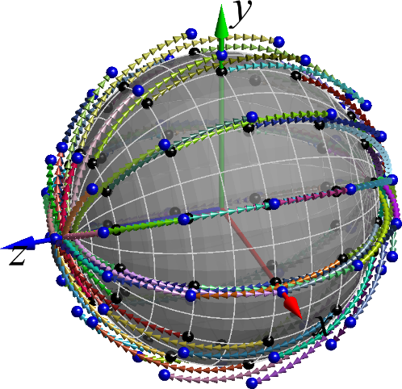

the AoA1 DL directions are plotted on top of the sphere with the black marker while the AoA2 DL directions are plotted slightly elevated from the sphere for clarity. The corresponding AoA1 & AoA2 pairs received by the UE are connected with arrows (pointing from AoA1 to AoA2) with the arrows plotted in random colours to support better differentiation. In the figures on the right, e.g.,

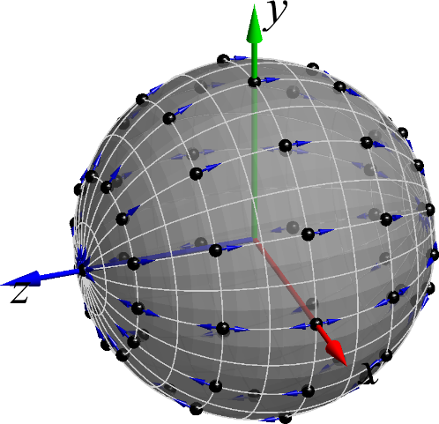

only the AoA1 DL directions are plotted on top of the sphere with the black marker while the direction towards the corresponding offset AoA2 DL direction is visualized with the single arrow (the length of the arrow corresponds to the value of the offset).

The following observations can be drawn from these figures:

- With probes aligned in the *xz* axis, the AoA1-AoA2 DL orientation vectors point towards the pole at q=180° for DL directions perceived from *y*≥0 while the AoA1-AoA2 DL orientation vectors point towards the pole at q=0° for DL directions perceived from *y*≤0

- With probes aligned in the *yz* axis, the AoA1-AoA2 DL orientation vectors point towards positive f for DL directions perceived from *y*≥0 while the AoA1-AoA2 DL orientation vectors point towards negative f for DL directions perceived from *y*≤0.

It was agreed that the directionality of the AoA1-AoA2 DL orientation vectors matters. For simulations, testing both +AoA offset and –AoA offset for each test point was considered the starting point. The intention is to accommodate the impact from directionality of the AoA1-AoA2 DL orientation vectors, i.e., to ensure no testing bias is introduced or whether it needs to be compensated somehow.

Table 5.3.5-1: Vectors of DL orientations between AoA1 (P0) and AoA2 from two different system configurations with AoA2 to AoA1 probe offsets of 60°, 120°, and 150° with a constant-step size grid using 84 grid points (Dq=Df=30°). Full rotation in q and half rotation in f.

|  |  |  |
| --- | --- | --- |
|  | Probes in the *xz* plane | Probes in the *yz* plane |
| System Configuration with full rotation in q and half rotation in f |  |  |
| Orientation between Probes P0 and P60 |  |  |
| Orientation between Probes P0 and P120 |  |  |
| Orientation between Probes P0 and P150 |  |  |

Table 5.3.5-2: Vectors of DL orientations between AoA1 (P0) and AoA2 from two different system configurations with AoA2 to AoA1 probe offsets of 60°, 120°, and 150° with a constant density grid using 50 grid points. Full rotation in q and half rotation in f.

|  |  |  |
| --- | --- | --- |
|  | Probes in the *xz* plane | Probes in the *yz* plane |
| System Configuration with full rotation in q and half rotation in f |  |  |
| Orientation between Probes P0 and P60 |  |  |
| Orientation between Probes P0 and P120 |  |  |
| Orientation between Probes P0 and P150 |  |  |

### 5.3.6 Far-field criteria

The Far-field criteria defined for the DFF UE RF test method described in clause 5.2.1.2 of [3] can be reused for the DFF-based measurement setup.

The Far-field criteria defined for the IFF UE RF test method described in clause 5.2.3.2 of [3] can be reused for the IFF-based measurement setup.

## 5.4 Calibration Measurement Procedure

### 5.4.1 Direct far field (DFF)

The calibration measurement per DFF probe is done by using a reference calibration antenna with known gain values. For the calibration measurement, the reference antenna is placed in the centre of the quiet zone. If an antenna with moving phase centre is used, a multi-segmented approach could be chosen where for multiple frequency segments the respective phase centre of the calibration antenna is placed in the centre of quiet zone. The calibration process determines the composite loss, Lpath,pol, of the entire transmission and receiver chain path gains (measurement antenna, amplification) and losses (switches, combiners, cables, path loss, etc.). The calibration measurement is repeated for each measurement path (two orthogonal polarizations and each signal path). Additional details of the calibration procedure are outlined in [11].

### 5.4.2 Indirect far field (IFF)

The calibration measurement per IFF probe is done by using a reference antenna (SGH used in Figure 5.2.2.1-1) with known efficiency or gain values. In the calibration measurement the reference antenna is measured in the same place as the DUT, and the attenuation of the complete transmission path (C↔A, as in Figure 5.2.2.1-1) from the DUT to the measurement receiver (EIRP), and from the RF source to DUT (EIS) is calibrated out. Figure 5.2.2.1-1 presents a setup of a typical compact antenna test range for EIRP calibration per IFF probe:

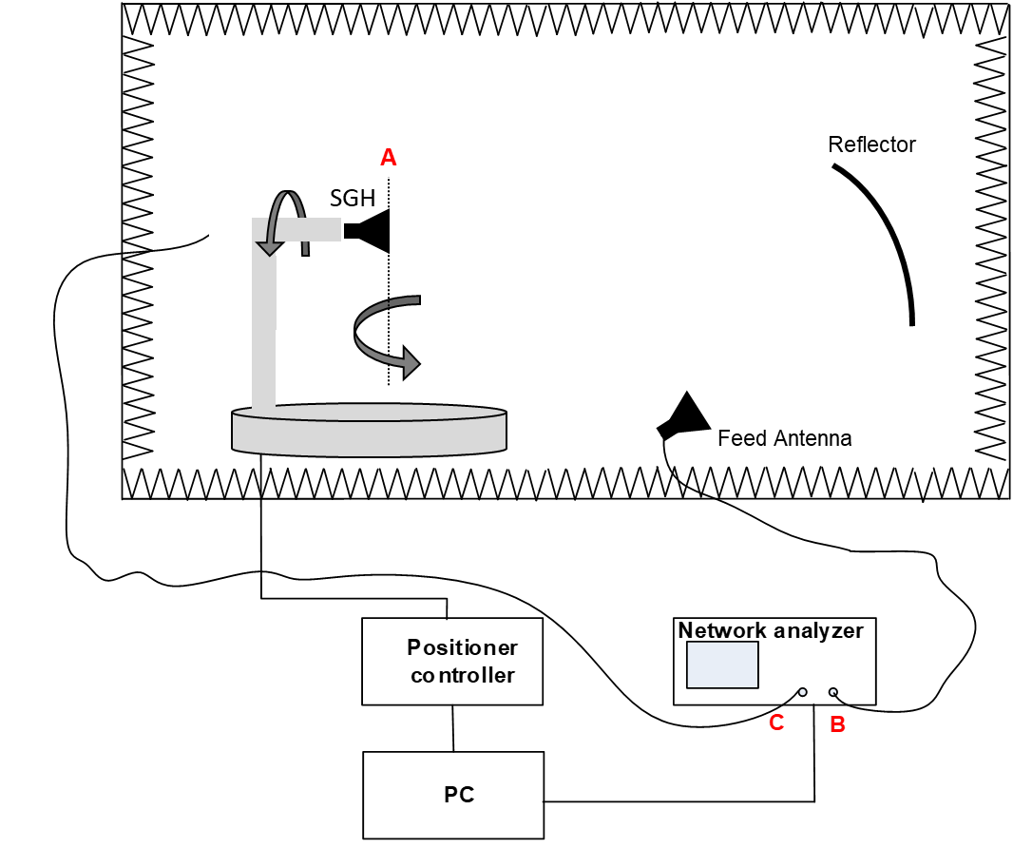

Figure 5.4.2-1. IFF/CATR calibration system setup per AoA for EIRP

## 5.5 Test procedure

The performance of simultaneous multi-Rx chain DL reception is measured by sampling the go/no-go result of the DUT with three-dimensional scan at various locations surrounding the device. The measurement is performed with a constant sampling step of 15 degree in both theta () and phi () axes.

The measurement procedure of the performance of simultaneous multi-Rx chain DL reception is illustrated in Figure 5.5-1.

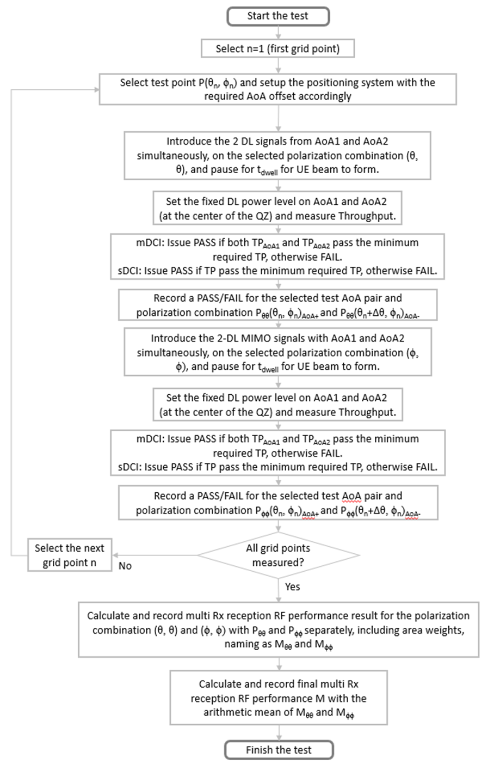

Figure 5.5-1: Illustration of the test procedure of simultaneous multi-Rx chain DL reception

# 6 UE RRM testing methodology for multi-Rx chain DL reception

## 6.1 General

This clause describes the UE RRM testing methodology for multi-Rx chain DL reception for FR2. The principle of selecting measurement setup for UE RRM testing is to reuse measurement setup for UE RF testing as much as possible to reduce the test system complexity and test cost.

Considering system complexity and feasibility, chamber footprint, upgradeabilisty of existing system, the measurement setup supporting Category 1 and Option 2 of Category 2 is selected as the baseline in Rel-18.

The details of OTA test environments including side conditions are to be discussed in the corresponding work item that may have impact to the core requirements.

## 6.2 Measurement setup

### 6.2.1 Baseline measurement setup

#### 6.2.1.1 Test scenarios

The test scenarios of UE RRM testing for multi-Rx chain DL reception can be divided into two categories depending on whether dual DCI simultaneously switching needs to be supported by measurement setup or not:

- Category 1: All the RRM test cases expect Dual TCI switching

- Category 2: Dual TCI switching test case

#### 6.2.1.2 Measurement setup for Category 1 scenario

The baseline measurement setup for Category 1 scenario is implemented based on the legacy 2AoA RRM setup specified in section 6 of [3]. An example measurement setup of multi-Rx chain DL reception RRM test case for Category 1 scenario is illustrated in Figure 6.2.1-1.

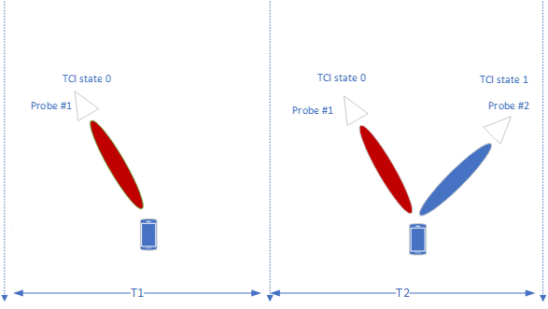

Figure 6.2.1-1: Example measurement setup for Category 1 scenario.

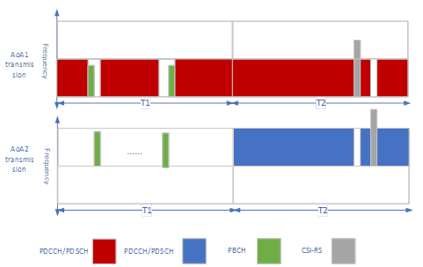

Figure 6.2.1-2: Example of Time and Frequency multiplexed downlink transmission for Category 1 scenario

As illustrated in Figure 6.2.1-2, PDCCH/PDSCH from two AoAs transmit in the FDM manner. PBCH measurement is based on TDM manner. For CSI-RS, the measurements could be based on TDM/FDM/CDM.

#### 6.2.1.3 Measurement setup for Category 2 scenario

Dual TCI switching is the key test case in multi-Rx chain DL reception RRM testing. To verify the performance of Dual TCI switching, the following 4 options were discussed:

- Option 1: Dual TCI switches simultaneously, probe number for multiple AoA test system is at least 4

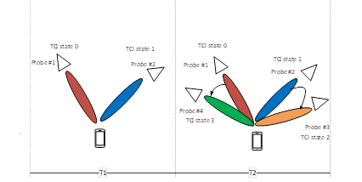

Figure 6.2.1-3: Example measurement setup for Option 1 of Category 2 scenario with 4 probes

For option 1, in the period of T1, DUT connects TCI state 0 and TCI state 1 via probe#1 and probe#2 respectively. Then in the period of T2, TCI state 0 switches to TCI state 3 via switching between probe#1 and probe#4, and in the meanwhile, TCI state 1 switches to TCI state 2 via switching between probe#2 and probe#3.

- Option 2: Dual TCI switches from one probe to two probes simultaneously, probe number for multiple AoA test system is at least 3

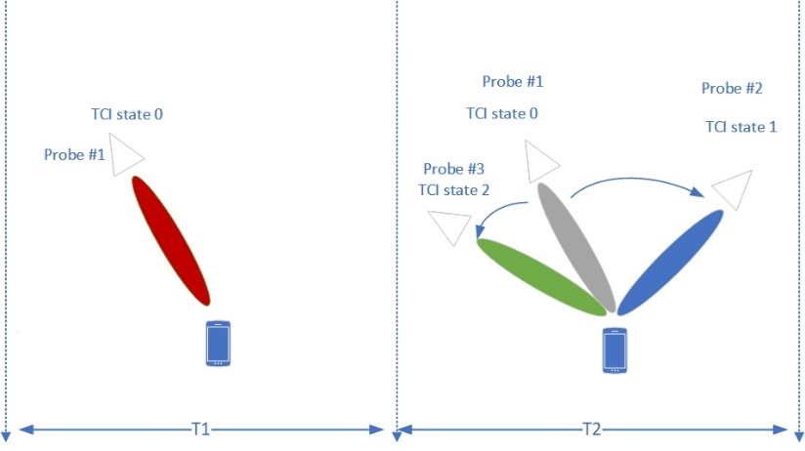

Figure 6.2.1-4: Example measurement setup for Option 2 of Category 2 scenario with 3 probes

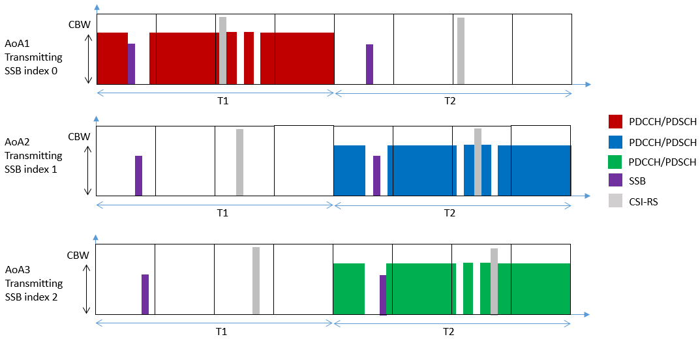

Figure 6.2.1-5: Example of Time and Frequency multiplexed downlink transmission for Category 2 scenario with 3 probes

For Option 2, in the period of T1, DUT connects TCI state 0 via Probe#1. In the period of T2, DUT measures the SSBs from Probe#2 and Probe#3 while keeping the connection from Probe 1. And then DUT simultaneously switches from Probe#1 to Probe#2 and #3.

An example measurement setup of multi-Rx chain DL reception RRM test case for Category 2 scenario with 3 probes is illustrated in Figure 6.2.1-5. PDCCH/PDSCH from two AoAs transmit in the FDM manner. PBCH measurement is based on TDM manner. For CSI-RS, the measurements could be based on TDM/FDM/CDM.

For the testing with Option 2, the side conditions for the period T1 and T1 are as follows. In the period of T1, the candidate test direction is selected from legacy EIS spherical coverage. In the period of T2, the candidate test directions (AoA pairs) are selected from multi-Rx spherical coverage requirements defined in UE RF core requirements.

Note that Figure 6.2.1-4 and Figure 6.2.1-5 show an example test procedure for Dual TCI switching. Other test procedures with at least 3 probes measurement setup are not precluded. The details of RRM test cases are to be discussed in the corresponding work item.

- Option 3: Dual TCI switches simultaneously, but the beam directions are not changed, probe number for multiple AoA test system is at least 2

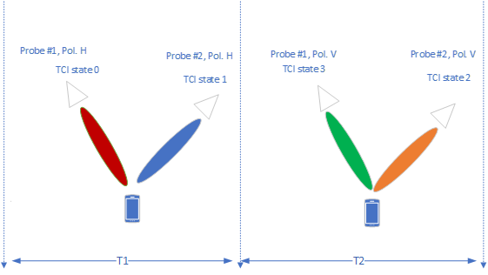

Figure 6.2.1-6: Example measurement setup for Option 3 of Category 2 scenario with 2 probes

For option 3, in the period of T1, DUT connects TCI state 0 and TCI state 1 via Pol.H of probe#1 and Pol.H of probe#2, respectively. Then in the period of T2, TCI state 0 switches to TCI state 3 via switching between Pol.H and Pol.V of probe 1, and in the meanwhile, TCI state 1 switches to TCI state 2 via switching between Pol.H and Pol.V of probe 2. Note that in option 3, different SSB IDs are transmitted from two polarizations in T1 and T2.

- Option 4: Switching AoAs of the Rx beam from AoA1 to AoA2 or vice versa during the TCI switching test. Probe number for multiple AoA test system is at least 2.

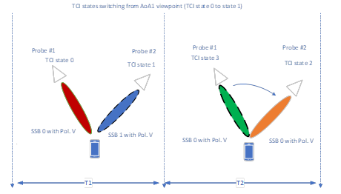

Figure 6.2.1-7 Example measurement setup for Option 4 of Category 2 scenario with 2 probes

For option 4, TCI state switching is based on SSB 0 to SSB 1. The test could be carried out simultaneously or in series with the switching.

The pros and cons for 4 options are listed in Table 6.2.1-1.

Table 6.2.1-1: Pros and cons for 4 options

|  |  |  |
| --- | --- | --- |
|  | Pros | Cons |
| Option 1 | - The setup can fully verify the performance of dual TCI switching. | - Test system will at least support 4 physical probes.  - Two of the same AoA offsets from RF session is needed.  - Reusing of existing test system is not possible |
| Option 2 | - The complexity of test system is lower, e.g., 3 physical probes is needed.  - The test condition could follow AoA offset from RF session.  - Reusing the existing is possible. | - The setup can partially verify the performance of dual TCI switching. |
| Option 3/4 | - The complexity of test system is lowest, e.g., 2 physical probes is needed. | - The setup cannot verify the real performance of dual TCI switching such as the beam directions are not changed from T1 to T2.  - This implies a perfect polarization alignment between DUT and TE in order to separate the beams, which is not feasible based on current test systems |

Considering system complexity and feasibility, chamber footprint, upgradeability of existing system, the measurement setup for Option 2 with at least 3 probes is selected as the baseline in Rel-18.

#### 6.2.1.4 Far-field criteria

For multi-Rx chain DL reception RRM baseline measurement setup based on DFF:

- The Far-field criteria defined for the DFF UE RF testing methodology described in clause 5.3.6 can be applied.

For multi-Rx chain DL reception RRM baseline measurement setup based on IFF:

- The Far-field criteria defined for the IFF UE RF testing methodology described in clause 5.3.6 can be applied.

#### 6.2.1.5 Calibration measurement procedure

The calibration measurement procedure defined for the DFF UE RF testing methodology described in clause 5.4.1 can be applied for DFF based UE RRM testing.

The calibration measurement procedure defined for the IFF UE RF testing methodology described in clause 5.4.2 can be applied for IFF based UE RRM testing.

#### 6.2.1.6 Reference point

For baseline measurement setup based on DFF and IFF, the reference point is located at the centre of the QZ. From the UE perspective the reference point is the input of UE antenna array.

The following Modes for useful signals (S) and noise signals (N) configuration have been identified and can be supported by the RRM test method:

- Mode 1 (SNR emulation): Test system transmits useful signals (S) and noise signals (N) to emulate target SNR condition.

- Mode 2 (noise-free transmission): Test system transmits only useful signals (S).

The test cases in core specification TS 38.133 [x] will be specified at the reference point, according to the following principles:

- Mode 1

- Specify absolute Noc level at the Reference point per angle of arrival (AoA)

- Noc level may have different value according to operating band and UE power class

- Mode 2

- Specify SNR at the Reference point per angle of arrival (AoA)

- SNR is a test-specific value

### 6.2.2 Test parameters

#### 6.2.2.1 Test parameters for Mode 1

For Mode 1, the SINR at baseband for multi-DCI with overlapping scheme is given as follows:

${SINR1}_{BB}=\frac{S1*G1*Loss}{\left(S2+N\right)G2*Loss+N*G1*Loss+Noise_floor}$, (6.2.2.1-1)

where S1 and S2 are signal level from AoA1 and AoA2 respectively. G1 and G2 are the antenna gain from AoA1 and AoA2 respectively. Loss is the pathloss between probe and DUT. Noise\_floor is the total noise at DUT baseband receiver. N is the artificial noise at the reference point from AoA1 and AoA2. The artificial noise level is identical from AoA1 and AoA22.

Since the wanted noise is set 6dB above UE thermal noise, therefore the total noise of baseband Noise\_floor can be ignored when calculating the SINR. And the SINR can be rewritten as:

${SINR1}_{BB}≈\frac{S1*G1*Loss}{\left(S2+N\right)G2*Loss+N*G1*Loss}=\frac{1}{\left(\frac{S2}{S1}+\frac{1}{SNR1}\right)*\frac{G2}{G1}+\frac{1}{SNR1}}$, (6.2.2.1-2)

where SINR1 is the SINR from probe 1, and the key parameter affecting the SINR at baseband is G1/G2.

Similarly, the SINR at baseband for multi-DCI with partially overlapping scheme is given as:

$SINR1≈\frac{1}{\left(\frac{ α*S2}{S1}+\frac{1}{SNR1}\right)*\frac{G2}{G1}+\frac{1}{SNR1}}$, (6.2.2.1-3)

where α indicates the ratio of overlapping resources (0<α<1).

For multi-Rx with non-overlapping scheme, the interference between two AoAs can be ignored. Then the test parameters for Mode 1 in the legacy RRM test methodology specified in [3] can be reused.

#### 6.2.2.2 Test parameters for Mode 2

For Mode 2, the SINR at baseband for multi-DCI with overlapping scheme is given as follows:

${SINR1}_{BB}=\frac{S1*G1*Loss}{S2*G2*Loss+Noise_floor}$, (6.2.2.2-1)

where S1 and S2 are signal level from AoA1 and AoA2 respectively. G1 and G2 are the antenna gain from AoA1 and AoA2 respectively. Loss is the pathloss between probe and DUT. Noise\_floor is the total noise at DUT baseband receiver.

If we set the signal level from interfering AoA direction at reference point is 6dB higher than UE thermal noise, then the approximate SINR can be rewritten as follows:

${SINR1}_{BB}≈\frac{S1}{S2*G2/G1}$. (6.2.2.2-2)

Same as for Mode 1, and the key parameter affecting the SINR at baseband is G1/G2.

Similarly, the SINR at baseband for multi-DCI with partially overlapping scheme is given as follows:

${SINR1}_{BB}≈\frac{S1}{α*S2*\frac{G2}{G1}},$ (6.2.2.2-3)

where α indicates the ratio of overlapping resources (0<α<1).

For multi-Rx with non-overlapping scheme, the interference between two AoAs can be ignored. Then the test parameters for Mode 2 in the legacy RRM test methodology specified in [3] can be reused.

# 7 UE demodulation and CSI testing methodology for multi-Rx chain DL reception

## 7.1 General

This clause describes the UE Demodulation testing methodology for multi-Rx chain DL reception for FR2. The ‘virtual cable’ approach is adopted per each multi-Rx chain in which the setup is to be fixed with the beamlock function. The framework for UE demodulation and CSI testing for multi-Rx chain DL reception is shown in Figure 7.1-1.

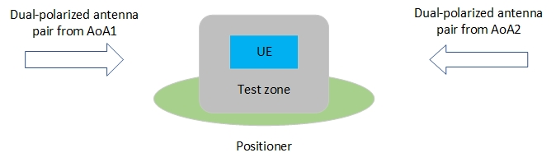

Figure 7.1-1: The framework for UE demodulation and CSI  
 testing for *multi-Rx chain DL reception*

## 7.2 Measurement setup

### 7.2.1 Baseline measurement setup

#### 7.2.1.1 Reference point

Virtual cable setup is adopted for the baseline measurement setup. For baseline measurement setup based on DFF and IFF, the reference point is located at the centre of the QZ. From the UE perspective the reference point is the input of UE antenna array.

#### 7.2.1.2 Far-field criteria

For multi-Rx chain DL reception demodulation baseline measurement setup based on DFF:

- The Far-field criteria defined for the DFF UE RF testing methodology described in clause 5.3.6 can be applied.

For multi-Rx chain DL reception demodulation baseline measurement setup based on IFF:

- The Far-field criteria defined for the IFF UE RF testing methodology described in clause 5.3.6 can be applied.

#### 7.2.1.3 Calibration measurement procedure

The calibration measurement procedure defined for the DFF UE RF testing methodology described in clause 5.4.1 can be applied for DFF based UE demodulation testing.

The calibration measurement procedure defined for the IFF UE RF testing methodology described in clause 5.4.2 can be applied for IFF based UE demodulation testing.

### 7.2.2 Test parameters

#### 7.2.2.1 Noc level configuration

Simulations for UE demodulation run at baseband with results expressed as SNRBB.The SNR at the reference point is the SNR configured by test equipment over-the-air expressed as SNRRP. The approach below is applied:

- Set wanted noise to give 1dB difference between Reference point SNR and Baseband SNR, using agreed UE requirements, i.e., SNRRP = SNRBB + 1dB

Noc level is set by the below equation for demodulation test on band Y:

Noc = REFSENSPC3, band Y, 50MHz -10log10(SCSREFSENS x PRBREFSENS x 12) - SNRREFSENS + ∆thermal + X, (7.2.2.1-1)

where

- REFSENSPC3, band Y, 50MHz is the REFSENS value in dBm specified for Power Class 3 UE in band Y for 50MHz channel bandwidth in TS 38.101-2 Table 7.3.2.3-1, [dBm/Hz]

- SCSREFSENS is a subcarrier spacing associated with NRB for 50MHz in TS 38.101-2 Table 5.3.2-1, chosen as 120kHz.

- PRBREFSENS is NRB associated with subcarrier spacing 120kHz for 50MHz in TS 38.101-2 Table 5.3.2-1 and is 32.

- 12 is the number of subcarriers in a PRB

- SNRREFSENS = -1 dB is the SNR used for simulation of REFSENS

- ∆thermal is the amount of dB that the wanted noise is set above UE thermal noise, giving a rise in total noise of ∆BB. ∆thermal = 6dB, giving a rise in total noise of 1dB.

- X = [3] is the allowable degradation in sensitivity from legacy REFSENS requirements in dB

#### 7.2.2.2 Criteria of UE test directions

The test directions and AoA separation for demodulation test can be declared by UE. The UE declared test directions shall satisfy the following 3 criteria:

-- Minimum isolation shall be at least [-12]dB

-- Rank number shall be higher or same as intended rank for a given test case

-- Each direction of AoA pair shall pass legacy REFSENS requirements with [3] dB degradation.

Note: the minimum isolation of [-12]dB is reused from legacy FR2 up to 2 layer demodulation testing. For multi-Rx chain DL reception demodulation testing, RAN4 recommend the target of the required SNR difference between with and without additional interference introduced by chamber, i.e., MU due to non-ideal isolation, is 1dB. The final minimum isolation and corresponding MU defer the discussion to RAN5.

# 8 Summary

This technical report defines the UE RF/RRM/demodulation test methodology for the verifications of these new requirements for FR2 UE with multi-Rx chain DL receptions. Through the analysis of system complexity, chamber footprint, upgradeability of existing system, development lead time, measurement uncertainty, and test time aspects, the agreements on measurement setup of UE RF/RRM/demodulation testing are as follows.

For UE RF testing, the measurement setup with full degrees of freedom for AoA1 with fixed angular Offset(s) between AoA1 and AoA2 is selected as the baseline.

For UE RRM testing, the measurement setup supporting Dual TCI switches from one probe to two probes simultaneously is selected as the baseline.

For UE demodulation testing, the measurement setup for UE RF testing can be reused to demodulation testing and the "virtual cable" approach is adopted per each multi-Rx chain.

Additionally, the preliminary measurement uncertainty budget is specified in the document and the final MU will be further discussed and decided by RAN5.

Annex A:  
Measurement uncertainty

# A.1 Measurement uncertainty budget for UE RF testing methodology

Similar as legacy FR2 UE RF testing methodology, the uncertainty tables shall be presented with two stages:

- Stage 1: the calibration of the absolute level of the DUT measurement results is performed by means of using a calibration antenna whose absolute gain is known at the frequencies of measurement

- Stage 2: the actual measurement with the DUT as either the transmitter or receiver is performed.

The uncertainty assessments for UE RF testing mainly refer to [13] taking into the impact from 2AoAs receptions. For multi-Rx chain DL reception UE RF requirements, the percentage of 2AoA spherical coverage is specified. Therefore, the new requirements of 2AoA are quite similar as legacy EIS spherical coverage requirements. While the difference between multi-Rx chain DL reception requirement and legacy EIS spherical coverage requirement measurement is that DL power is not scanning with a DL power step size in multi-Rx chain DL reception UE RF testing. It says in multi-Rx chain DL reception UE RF testing, the throughput of UE is measured at a fixed DL power, i.e., legacy EIS spherical coverage power level.

As specified in Table B.19.2-2 of [13], each MU element is described as dB value that could not totally apply for multi-Rx chain DL reception UE MU analysis. Additionally, the difference of probability between candidate measurement grids measurement step size could be evaluated and provided based on the simulations. Therefore, it is agreed to use the percentage value as the metric for the 2AoA UE RF MU analysis.

The preliminary MU budget for UE RF testing methodology is defined in Table A.1-1 and Table A.1-2.

Table A.1-1: Uncertainty assessment for wanted DL signal absolute power in 2AoA coverage measurement with IFF

| UID | Uncertainty source | Uncertainty value | Distribution of the probability | Divisor | Standard uncertainty (σ) [dB] |
| --- | --- | --- | --- | --- | --- |
| Stage 2: DUT measurement | | | | | |
| 1 | Positioning misalignment | 0.00 | Normal | 2.00 | [0.00] |
| 2 | Measure distance uncertainty | 0.00 | Rectangular | 1.73 | [0.00] |
| 3 | Quality of Quiet Zone (NOTE 1) | 0.7 | Actual | 1.00 | [0.7] |
| 4 | Mismatch | 1.30 | Actual | 1.00 | [1.30] |
| 5 | Standing wave between the DUT and measurement antenna | 0.00 | U-shaped | 1.41 | [0.00] |
| 6 | gNB uncertainty on absolute level | 2.9 | Normal | 2.00 | [1.45] |
| 7 | Phase curvature | 0.00 | U-shaped | 1.41 | [0.00] |
| 8 | Amplifier uncertainties | 2.1 | Normal | 2.00 | [1.05] |
| 9 | Random uncertainty | 0.50 | Normal | 2.00 | [0.25] |
| 10 | Influence of the XPD | 0.01 | U-shaped | 1.41 | [0.00] |
| 11 | Insertion Loss Variation | 0.00 | Rectangular | 1.73 | [0.00] |
| 12 | RF leakage (from measurement antenna to the receiver/transmitter) | 0.00 | Actual | 1.00 | [0.00] |
| 13 | Multiple measurement antenna uncertainty | 0.15 | Actual | 1.00 | [0.15] |
| 14 | DUT repositioning | 0.00 | Rectangular | 1.73 | [0.00] |
| 15 | Influence of spherical coverage grid | 0.12 | Actual | 1 | [0.12] |
| Stage 1: Calibration measurement | | | | | |
| 16 | Mismatch | 0.00 | U-shaped | 1.41 | [0.00] |
| 17 | Amplifier Uncertainties | 0.00 | Normal | 2.00 | [0.00] |
| 18 | Misalignment of positioning System | 0.00 | Normal | 2.00 | [0.00] |
| 19 | Uncertainty of the Network Analyzer | 1.50 | Normal | 2.00 | [0.75] |
| 20 | Uncertainty of the absolute gain of the calibration antenna | 0.60 | Normal | 2.00 | [0.30] |
| 21 | Positioning and pointing misalignment between the reference antenna and the measurement antenna | 0.01 | Rectangular | 1.73 | [0.00] |
| 22 | Phase centre offset of calibration antenna | 0.00 | Rectangular | 1.73 | [0.00] |
| 23 | Quality of quiet zone for calibration process (NOTE 1) | 0.4 | Actual | 1.00 | [0.4] |
| 24 | Standing wave between reference calibration antenna and measurement antenna | 0.00 | U-shaped | 1.41 | [0.00] |
| 25 | Influence of the calibration antenna feed cable | 0.14 | Normal | 2.00 | [0.07] |
| 26 | Insertion Loss Variation | 0.00 | Rectangular | 1.73 | [0.00] |
|  | Measurement uncertainty | | | | Value |
| Wanted DL signal absolute power (1.96σ - confidence interval of 95 %) [dB] | | | | | [4.92] |
| NOTE 1: The values from Enhanced IFF seem rather optimistic for MultiRX and should be further updated with the considerations of 2AoA impact | | | | | |

A.1-2: Total uncertainty assessment for 2AoA coverage measurement with IFF

| Measurement uncertainty | Value |
| --- | --- |
| Wanted DL signal absolute power (1.96σ - confidence interval of 95 %) [%] (NOTE 1) | [4.0]% |
| Uncertainty related to measurement grid (NOTE 1) | [2.3]% |
| Total Measurement uncertainty | Value |
| [2AoA spherical coverage] expanded uncertainty (1.96σ - confidence interval of 95 %) [%] | [6.3]% |
| NOTE 1: It is derived based on the simulations with different DL power vs percentage of 2AoA metric.  NOTE 2: It is derived based on the simulations with measurement step size vs percentage of 2AoA metric. | |

# A.2 Measurement uncertainty budget for UE RRM testing methodology

The preliminary uncertainty budget for UE RRM testing is defined in Table A.2-1.

Table A.2-1: Uncertainty assessment for RRM testing with IFF

| UID | Uncertainty source | Uncertainty value | Distribution of the probability | Divisor | Standard uncertainty (σ) [dB] |
| --- | --- | --- | --- | --- | --- |
| Stage 2: DUT measurement | | | | | |
| 1 | Positioning misalignment | 0.00 | Normal | 2.00 | [0.00] |
| 2 | Measure distance uncertainty | 0.00 | Rectangular | 1.73 | [0.00] |
| 3 | Quality of Quiet Zone (NOTE 1) | 0.7 | Actual | 1.00 | [0.7] |
| 4 | Mismatch | 1.30 | Actual | 1.00 | [1.30] |
| 5 | Standing wave between the DUT and measurement antenna | 0.00 | U-shaped | 1.41 | [0.00] |
| 6 | gNB uncertainty on absolute level | 2.9 | Normal | 2.00 | [1.45] |
| 7 | Phase curvature | 0.00 | U-shaped | 1.41 | [0.00] |
| 8 | Amplifier uncertainties | 2.1 | Normal | 2.00 | [1.05] |
| 9 | Random uncertainty | 0.50 | Normal | 2.00 | [0.25] |
| 10 | Influence of the XPD | 0.01 | U-shaped | 1.41 | [0.00] |
| 11 | Insertion Loss Variation | 0.00 | Rectangular | 1.73 | [0.00] |
| 12 | RF leakage (from measurement antenna to the receiver/transmitter) | 0.00 | Actual | 1.00 | [0.00] |
| 13 | Multiple measurement antenna uncertainty | 0.15 | Actual | 1.00 | [0.15] |
| 14 | DUT repositioning | 0.08 | Rectangular | 1.73 | [0.05] |
| Stage 1: Calibration measurement | | | | | |
| 15 | Mismatch | 0.00 | U-shaped | 1.41 | [0.00] |
| 16 | Amplifier Uncertainties | 0.00 | Normal | 2.00 | [0.00] |
| 17 | Misalignment of positioning System | 0.00 | Normal | 2.00 | [0.00] |
| 18 | Uncertainty of the Network Analyzer | 0.73 | Normal | 2.00 | [0.37] |
| 19 | Uncertainty of the absolute gain of the calibration antenna | 0.60 | Normal | 2.00 | [0.30] |
| 20 | Positioning and pointing misalignment between the reference antenna and the measurement antenna | 0.01 | Rectangular | 1.73 | [0.00] |
| 21 | Phase centre offset of calibration antenna | 0.00 | Rectangular | 1.73 | [0.00] |
| 22 | Quality of quiet zone for calibration process (NOTE 1) | 0.4 | Actual | 1.00 | [0.4] |
| 23 | Standing wave between reference calibration antenna and measurement antenna | 0.00 | U-shaped | 1.41 | [0.00] |
| 24 | Influence of the calibration antenna feed cable | 0.14 | Normal | 2.00 | [0.07] |
| 25 | Insertion Loss Variation | 0.00 | Rectangular | 1.73 | [0.00] |
|  | Systematic uncertainties (NOTE 2) | | | | Value |
| Total measurement uncertainty | | | | | Value |
| DL AWGN absolute power expanded uncertainty (1.96σ - confidence interval of 95 %) [dB] | | | | | [4.75] |
| NOTE 1: The values from Enhanced IFF seem rather optimistic for MultiRX and should be further updated with the considerations of 2AoA impact | | | | | |

# A.3 Measurement uncertainty budget for UE demodulation testing methodology

The preliminary uncertainty budget for UE demodulation testing is defined in Table A.3-1.

Table A.3-1: Uncertainty assessment for Multi-Rx demodulation testing with IFF

| UID | Uncertainty source | Uncertainty value | Distribution of the probability | Divisor | Standard uncertainty (σ) [dB] |
| --- | --- | --- | --- | --- | --- |
| Signal-to-noise ratio uncertainty | | | | | |
| Stage 2: DUT measurement | | | | | |
| 1 | Positioning misalignment |  | [Normal] | [2.00] |  |
| 2 | Measure distance uncertainty |  | [Rectangular] | [1.73] |  |
| 3 | Quality of Quiet Zone (NOTE 1) |  | [Actual] | [1.00] |  |
| 4 | Mismatch |  | [Actual] | [1.00] |  |
| 5 | Standing wave between the DUT and measurement antenna |  | [U-shaped] | [1.41] |  |
| 6 | gNB emulator SNR uncertainty |  | [Normal] | [2.00] |  |
| 7 | Phase curvature |  | [U-shaped] | [1.41] |  |
| 8 | Amplifier uncertainties |  | [Normal] | [2.00] |  |
| 9 | Random uncertainty |  | [Normal] | [2.00] |  |
| 10 | Influence of the XPD |  | [U-shaped] | [1.41] |  |
| 11 | Insertion Loss Variation |  | [Rectangular] | [1.73] |  |
| 12 | RF leakage (from measurement antenna to the receiver/transmitter) |  | [Actual] | [1.00] |  |
| 13 | Multiple measurement antenna uncertainty |  | [Actual] | [1.00] |  |
| 14 | DUT repositioning |  | [Rectangular] | [1.73] |  |
| Stage 1: Calibration measurement | | | | | |
| 15 | Mismatch |  | [U-shaped] | [1.41] |  |
| 16 | Amplifier Uncertainties |  | [Normal] | [2.00] |  |
| 17 | Misalignment of positioning System |  | [Normal] | [2.00] |  |
| 18 | Uncertainty of the Network Analyzer |  | [Normal] | [2.00] |  |
| 19 | Uncertainty of the absolute gain of the calibration antenna |  | [Normal] | [2.00] |  |
| 20 | Positioning and pointing misalignment between the reference antenna and the measurement antenna |  | [Rectangular] | [1.73] |  |
| 21 | Phase centre offset of calibration antenna |  | [Rectangular] | [1.73] |  |
| 22 | Quality of quiet zone for calibration process (NOTE 1) |  | [Actual] | [1.00] |  |
| 23 | Standing wave between reference calibration antenna and measurement antenna |  | [U-shaped] | [1.41] |  |
| 24 | Influence of the calibration antenna feed cable |  | [Normal] | [2.00] |  |
| 25 | Insertion Loss Variation |  | [Rectangular] | [1.73] |  |
|  | Systematic uncertainties | | | | Value |
| 26 | Impact on non-ideal isolation between branches for the wireless cable mode | | | | TBD (NOTE 2) |
| **Total Signal-to-Noise ratio uncertainty** | | | | | |
|  | | | | |  |
| Other contributors affecting test result | | | | | |
| 27 | gNB emulator fading model impairments |  | [Normal] | [2.00] |  |
| 28 | AWGN flatness and signal flatness, max deviation for any Resource Block, relative to average over BWConfig |  | [Actual] | 1.00 |  |
| 29 | Result variation due to finite test time |  | [Actual] | [1.00] |  |
| NOTE 1: The values from Enhanced IFF seem rather optimistic for MultiRX and should be further updated with the considerations of 2AoA impact  NOTE 2: FFS which is relying on the min. isolation requirements. | | | | | |

Annex B:  
UE coordinate system

# B.1 Reference coordinate system

This annex defines the measurement coordinate system for the NR UE. The reference coordinate system is provided in Figure B.1-1 below while Figure B.1-2 shows the DUT in the default alignment, i.e., the DUT and the reference coordinate systems are aligned with α = 0o and β = 0o and γ = 0o where α, β, and γ describe the relative angles between the two coordinate systems.

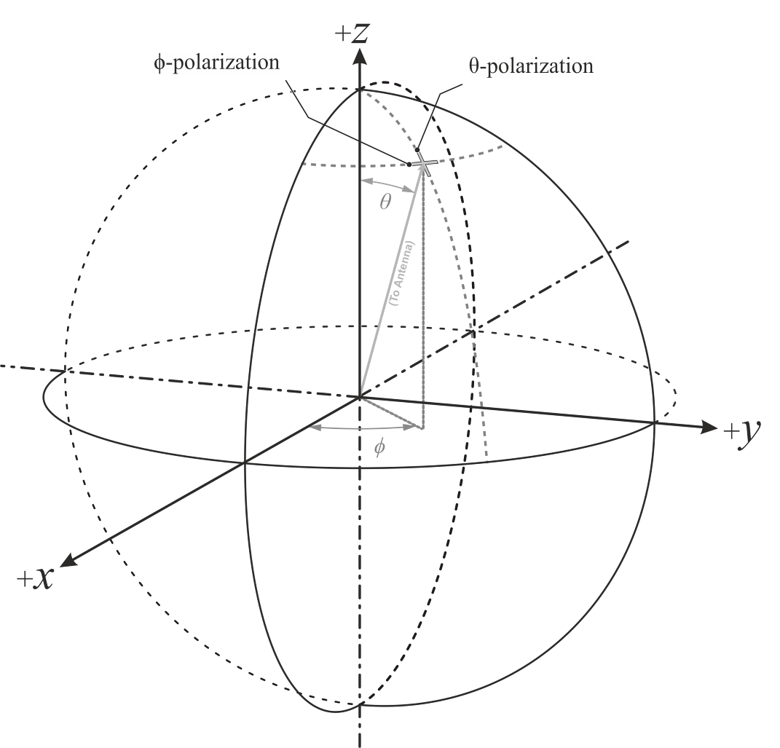

**Figure B.1-1: Reference coordinate system**

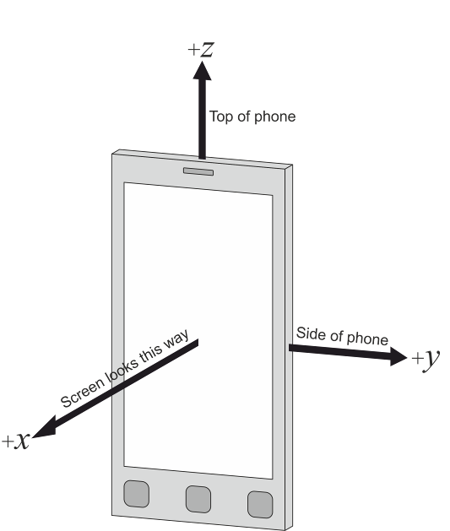

Figure B.1-2: DUT default alignment to coordinate system

The following aspects are necessary:

- A basic understanding of the top and bottom of the device is needed in order to define unambiguous DUT positioning requirements for the test, e.g., in the drawings used in this annex, the three buttons are on the bottom of the device (front) and the camera is on the top of the device (back).

- An understanding of the origin and alignment the coordinate system inside the test system, i.e. the directions in which the x, y, z axes point inside the test chamber, is needed in order to define unambiguous DUT orientation, DUT beam, signal, interference, and measurement angles.

# B.2 Alternate coordinate system for 2AoA testing

Considering +AoA and -AoA are always on the meridian, the Reference coordinate system is used for Rel-18 multi-Rx testing. The Alternate coordinate system could be considered for the cases when the AoA pairs do not lie along the same meridian.

The performance of UEs with multi-Rx chain reception DL with 2 active AoA is agreed to be measured with 3D scan on the spherical surface using constant step size grids. Therefore, the test point of AoA1 on the spherical surface can be expressed as $\left(θ, ϕ\right)$ in the same way it is defined for legacy RF testing with 1 AoA. In the case of the AoA2, the test points require certain angle separation with respect to AoA1. However, the direction of AoA2, which is also called as “AoA1-AoA2 DL Orientation Vector” in clause 5.3.5, may introduce ambiguity without additional instructions. The situation is illustrated in Figure B.2-1.

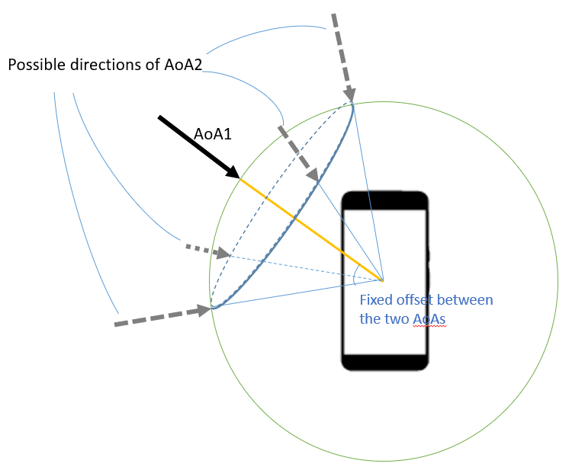

Figure B.2-1 Illustration of possible AoA pairs on the test point of AoA1

In order to simplify the representation of the AoA pairs per test points of AoA1, the alternate coordinate system nomenclature described in this section can be used to express the AoA pairs with one coordinate, and it could be used also for the situation whereAoA2 does not lie in the same meridian as of AoA1.

In this alternate coordinate system nomenclature for 2AoA testing. the Reference coordinates of AoA1 (θ, ϕ) could be extended to $\left(θ, ϕ,ω\right)$ (θ, ϕ, ω), where ω corresponds to the AoA1-AoA2 DL Orientation Vector. In detail, ω is the angle between the AoA1-AoA2 DL Orientation Vector and the reference axis in the assistant plane.

The assistant plane is orthogonal to the AoA1 direction , and the Z’ axis correspond to the projection of the meridian (points with same fixed $ϕ$ angle) of AoA1 into the assistant plane. I.e. in case of $θ<90º$, +Z’ corresponds to the cross point of +Z axis and the assistant plane (see Figure B.2-2a). In case of $θ>90º$, -Z’ corresponds to the cross point of -Z axis and the assistant plane (see Figure B.2-2b).

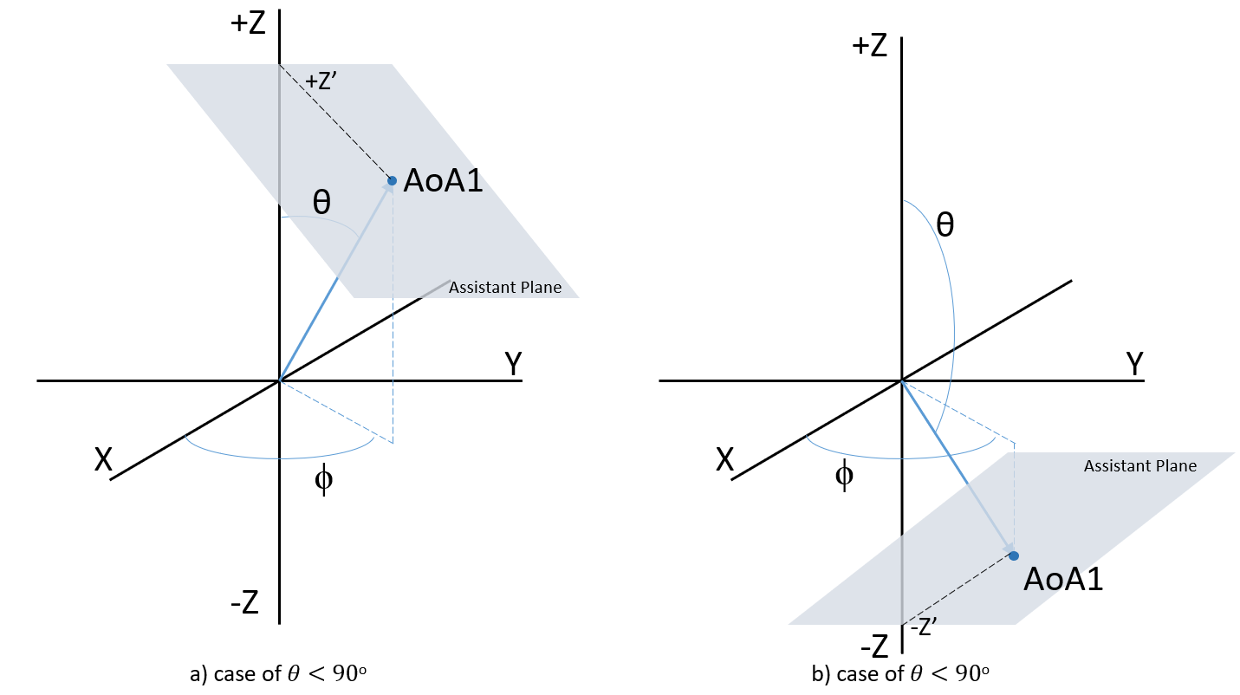

Figure B.2-2 Illustration of Assistant Plane of the alternate coordinate system

Finally, ω is the angle from the reference axis Z’ to the AoA1-AoA2 DL Orientation Vector in clockwise direction (see Figure B.2-3).

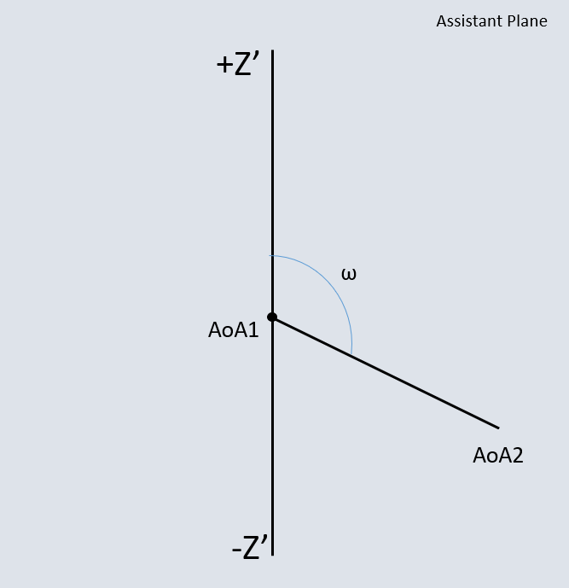

Figure B.2-3 Illustration of angle ω in the alternate coordinate system

This alternate coordinate system can also cover the theoretical cases when the AoA pairs do not lie along the same meridian, and eliminate the possible ambiguity on test point expression.

# B.3 Test conditions and angle definitions

<Editor’s note: the figures in tables B.3-1 through B.3-3 need to be updated to align with existing definition in TS 38.101-2>

This sub-annex provides the test conditions and angle definitions for twelve permitted device orientations for the initial test condition. With the convenience of defining the permitted alignments/orientations, they are divided into three groups as shown from Table B.3-1 to Table B.3-3. The DUT orientation to be tested is chosen from Table B.3-1, Table B.3-2 and Table B.3-3 by UE vendor declaration.

Table B.3-1: Test conditions and angle definitions for Alignment Option 1

|  |  |  |
| --- | --- | --- |
| Test condition | DUT orientation | Diagram |
| Orientation 1  (Option 1) | α = 0º; β = 0º; γ = 0º |  |
| Orientation 1  (Option 2) | α = 0º; β = 0º; γ = 180º |  |
| Orientation 2  (Option 1) | α = 180º; β = 0º; γ = 0º |  |
| Orientation 2  (Option 2) | α = 0º; β = 180º; γ = 0º |  |
| NOTE 1: The combination of rotations is captured by matrix M=*Rz*()•*Ry*()•*Rx*() | | |

Table B.3-2: Test conditions and angle definitions for Alignment Option 2

|  |  |  |
| --- | --- | --- |
| Test condition | DUT orientation | Diagram |
| Orientation 1  (Option 1) | α = 0º; β = -90º; γ = 0º |  |
| Orientation 1  (Option 2) | α = 0º; β = -90º; γ = 180º |  |
| Orientation 2  (Option 1) | α = 180º; β = 90º; γ = 0º |  |
| Orientation 2  (Option 2) | α = 0º; β = 90º; γ = 0º |  |
| NOTE 1: The combination of rotations is captured by matrix M=*Rz*()•*Ry*()•*Rx*() | | |

Table B.3-3: Test conditions and angle definitions for Alignment Option 3

|  |  |  |
| --- | --- | --- |
| Test condition | DUT orientation | Diagram |
| Orientation 1  (Option 1) | α = 90º; β = 0º; γ = 0º |  |
| Orientation 1  (Option 2) | α = 90º; β = 0º; γ = 180º |  |
| Orientation 2  (Option 1) | α = -90º; β = 0º; γ = 0º |  |
| Orientation 2  (Option 2) | α = 90º; β = 180º; γ = 0º |  |
| NOTE 1: The combination of rotations is captured by matrix M=*Rz*()•*Ry*()•*Rx*() | | |

For each UE requirement and test case, each of the parameters in Table B.3-1 to Table B.3-3 need to be recorded, such that DUT positioning, DUT beam direction, and angles of the signal, link/interferer, and measurement are specified in terms of the fixed coordinate system.

Due to the non-commutative nature of rotations, the order of rotations is important and needs to be defined when multiple DUT orientations are tested.

The rotations around the x, y, and z axes can be defined with the following rotation matrices





and

.

with the respective angles of rotation, **, **, ** and



Additionally, any translation of the DUT can be defined with the translation matrix



with offsets tx, ty, tz in x, y, and z, respectively and with



The combination of rotations and translation is captured by the multiplication of rotation and translation matrices.

For instance, the matrix M

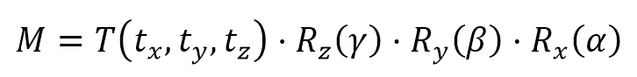

describes an initial rotation of the DUT around the x axis with angle *α*, a subsequent rotation around the y axis with angle *β*, and a final rotation around the z axis with angle *γ*. After those rotations, the DUT is translated by tx, ty, tz in x, y, and z, respectively.

# B.4 DUT positioning guidelines

<Editor’s note: additional details to be added for the re-positioning concept for multi-Rx performance measurements >

The centre of the reference coordinate system shall be aligned with the geometric centre of the DUT in order to minimize the offset between antenna modules integrated at any position of the UE and the centre of the quiet zone.

Near-field coupling effects between the antenna and the pedestals/positioners/fixtures generally cause increased signal ripples. Re-positioning approach is adopted for multi-Rx performance measurements to avoid AoA blockage.

As the starting point, the initial positioner/UE orientation is selected to be (-90° - ½ angular separation). The minimum angular separation between positioner and probe(s) are listed in Table B.4-1 as below.

Table B.4-1: Minimum angular separation between positioner and probe(s)

|  |  |
| --- | --- |
| **Declared Angular Separation [°]** | **Min Angular Separation between Positioner and Probe(s) [°]** |
| 30 | 75 |
| 60 | 60 |
| 90 | 45 |
| 120 | 30 |
| 150 | 15 |

Annex G:  
Step size of measurement grids

This appendix describes the assumptions and definition of the minimum number of measurement grid points for multi-Rx chain DL reception UE RF testing.

The minimum number of measurement grid point for TRP/EIRP/EIS was investigated in [3] in which a completely random fashion is applied for both  and  dimensions. For multi-Rx chain DL reception UE RF testing, it has already known that measured performance of a UE is expected to systematically vary as a function of position. This systematic variation means that the strategy to completely randomize the orientation of the UE to determine MU does not apply. Moreover, for the measurement grid analysis for multi-Rx, the AoA pairs lie along longitudes of the UE reference coordination system, and the requirements apply only for the UE-declared orientation in the positioner. Therefore, it is agreed that uncertainty mechanism for multi-Rx chain DL reception UE RF testing is limited to the coarseness of the grid and doesn’t depend on the UE random orientations as the legacy approach.

Through the analysis from simulation results with antenna configuration of 6x2 and 4x2, 15deg is selected as the step size of constant-step grid.

# G.1 Simulation results for step size

In this clause, the simulation results with 1deg, 2deg, 5deg, 10deg, 15deg, and 30deg step sizes are shown in Table G.1-1 and Table G.1-2 considering different antenna modules placements.

Table G.1-1: Simulation results for step size with antenna configuration of 4x2

|  |  |  |  |  |  |  |  |
| --- | --- | --- | --- | --- | --- | --- | --- |
| **Adjacent modules** | | | | | | | |
|  |  | 30 | 60 | 90 | 120 | 150 | 180 |
| Samsung - OR | 10deg | 0.00% | -0.08% | -0.27% | 0.32% | 0.17% | 0.16% |
| Samsung - OR | 15deg | 0.21% | 0.28% | 0.23% | 0.56% | -0.08% | -0.56% |
| vivo - Arithmetic | 10deg | -0.30% | -0.50% | 0.10% | 0.20% | 0.10% | - |
| vivo - Arithmetic | 15deg | -0.20% | -1.00% | -0.70% | -1.10% | -0.10% | - |
| QC- OR | 10deg | - | 0.10% | 0.20% | 0.80% | 0.60% | 0.00% |
| QC - OR | 15deg | - | 1.60% | 0.30% | 2.60% | 2.60% | 1.50% |
| QC - Arithmetic | 10deg | - | -0.10% | 0.10% | 0.40% | 0.20% | 0.00% |
| QC - Arithmetic | 15deg | - | 1.20% | 0.10% | 1.30% | 1.90% | 1.50% |
| OPPO | 10deg | 0.21% | 0.54% | 0.27% | 0.82% | 0.84% | 0.39% |
| OPPO | 15deg | 0.97% | 0.26% | 1.47% | 0.38% | 0.20% | 0.53% |
| Huawei – OR | 10deg | -0.5% | -0.2% | -0.2% | 0.3% | -0.2% | -0.5% |
| Huawei - OR | 15deg | 0.1% | 0.6% | 0.6% | 0.9% | 0.3% | 0.1% |
| **Back-to-back modules** | | | | | | | |
|  |  | 30 | 60 | 90 | 120 | 150 | 180 |
| Samsung -OR | 10deg | 0.04% | -0.11% | 0.09% | 0.25% | 0.10% | 0.09% |
| Samsung - OR | 15deg | -0.15% | -0.43% | -0.72% | -0.35% | -0.43% | -0.41% |
| vivo - Arithmetic | 10deg | 0.20% | -0.50% | 0.10% | -0.20% | -1.50% | - |
| vivo - Arithmetic | 15deg | 0.60% | 1.30% | 0.50% | 0.20% | 1.20% | - |
| QC - OR | 10deg | - | 1.20% | 0.10% | -1.10% | -0.70% | -1.30% |
| QC - OR | 15deg | - | 1.50% | 0.40% | -3.20% | -2.80% | -2.20% |
| QC - Arithmetic | 10deg | - | 0.60% | 0.10% | -0.20% | -0.50% | -1.30% |
| QC - Arithmetic | 15deg | - | 0.70% | 0.30% | -0.90% | -1.90% | -2.20% |
| OPPO | 10deg | 2.93% | 3.48% | 0.16% | 2.74% | 0.81% | 1.29% |
| OPPO | 15deg | 3.65% | 4.56% | 0.41% | 0.77% | 1.22% | 1.03% |
| Huawei – OR | 10deg | 0.1% | 0.3% | 0.2% | -0.3% | 0.5% | - |
| Huawei - OR | 15deg | 0.4% | -0.6% | 0.8% | 0.4% | 0.9% | - |
| **Same side modules** | | | | | | | |
|  |  | 30 | 60 | 90 | 120 | 150 | 180 |
| Samsung - OR | 10deg | -0.02% | 0.10% | 0.28% | 0.25% | 0.31% | 0.04% |
| Samsung - OR | 15deg | -0.16% | -0.35% | -0.08% | -0.23% | 0.07% | -0.30% |
| vivo - Arithmetic | 10deg | -1.20% | 0.50% | 0.10% | 1.00% | 0.50% | - |
| vivo - Arithmetic | 15deg | -0.40% | -0.40% | -0.20% | 0.40% | -0.40% | - |
| OPPO | 10deg | 1.25% | 0.24% | 0.50% | 0.23% | 2.66% | 1.96% |
| OPPO | 15deg | 0.24% | 1.74% | 2.08% | 0.25% | 1.35% | 1.10% |
| Huawei – OR | 10deg | -0.4% | 0.2% | 0.3% | 0.6% | 0.4% | -0.4% |
| Huawei - OR | 15deg | -0.2% | -0.5% | -0.2% | 0.3% | 0.1% | -0.2% |

Table G.1-2: Simulation results for step size with antenna configuration of 6x2

|  |  |  |  |  |  |  |  |
| --- | --- | --- | --- | --- | --- | --- | --- |
| **Adjacent modules** | | | | | | | |
|  |  | 30 | 60 | 90 | 120 | 150 | 180 |
| Samsung - OR | 10deg | 0.05% | -0.03% | 0.00% | 0.02% | -0.14% | -0.12% |
| Samsung - OR | 15deg | 0.12% | -0.13% | -0.20% | 0.04% | -0.44% | -0.39% |
| QC- OR | 10deg | - | 0.10% | -0.20% | 0.40% | 0.50% | 0.00% |
| QC - OR | 15deg | - | 1.40% | 0.50% | 2.70% | 2.70% | 1.80% |
| QC - Arithmetic | 10deg | - | -0.10% | -0.30% | 0.20% | 0.20% | 0.00% |
| QC - Arithmetic | 15deg | - | 1.10% | 0.60% | 1.30% | 2.00% | 1.80% |
| **Back-to-back modules** | | | | | | | |
|  |  | 30 | 60 | 90 | 120 | 150 | 180 |
| Samsung -OR | 10deg | - | - | - | - | - | - |
| Samsung - OR | 15deg | - | - | - | - | - | - |
| QC - OR | 10deg | - | 0.80% | -1.30% | -2.60% | -1.60% | -2.00% |
| QC - OR | 15deg | - | 1.90% | 2.50% | -1.30% | -2.10% | 1.00% |
| QC - Arithmetic | 10deg | - | 0.40% | -0.60% | -1.00% | -1.40% | -2.00% |
| QC - Arithmetic | 15deg | - | 0.90% | 1.30% | 0.30% | -0.90% | 1.00% |
| **Same side modules** | | | | | | | |
|  |  | 30 | 60 | 90 | 120 | 150 | 180 |
| Samsung - OR | 10deg | -0.07% | 0.15% | 0.06% | -0.17% | 0.07% | 0.01% |
| Samsung - OR | 15deg | 0.23% | 0.16% | 0.23% | -0.35% | -0.04% | -0.26% |

Annex H:  
Change history

|  |  |  |  |  |  |  |  |
| --- | --- | --- | --- | --- | --- | --- | --- |
| **Change history** | | | | | | | |
| **Date** | **Meeting** | **TDoc** | **CR** | **Rev** | **Cat** | **Subject/Comment** | **New version** |
| 2022-08 | RAN4#104e | R4-2213182 |  |  |  | Initial skeleton | 0.0.1 |
| 2023-03 | RAN4#106 | R4-2300085 |  |  |  | The following TPs were agreed:  - R4-2300086, TP on TR 38.871 for editorial correction and general aspects, Qualcomm Incorporated  - R4-2302924, TP to introduce Multi-AoA UE RF Test Aspects, Keysight Technologies UK Ltd  - R4-2302150, TP on TR 38.871 calibration measurement procedure, Huawei, HiSilicon | 0.1.0 |
| 2023-04 | RAN4#106bis-e | R4-2305886 |  |  |  | The following TP was agreed:  - R4-2305886, TP to introduce Multi-AoA UE RF Test Aspects, Keysight Technologies | 0.2.0 |
| 2023-05 | RAN4#107 | R4-2309247 |  |  |  | The following TPs were agreed:  - R4-2309287, TP to TR 38.871 on 3-axis positioner considerations, Qualcomm Incorporated  - R4-2309246, TP to TR 38.871 on RRM test method, Qualcomm Incorporated | 0.3.0 |
| 2023-08 | RAN4#108 | R4-2312890 |  |  |  | The following TPs were agreed:  - R4-2313887, TP for assistant coordination system, OPPO, ROHDE & SCHWARZ, Qualcomm Incorporated  - R4-2312889, TP to TR38.871 on UE RF testing methodology, Qualcomm Incorporated | 0.4.0 |
| 2023-10 | RAN4#108bis | R4-2316513 |  |  |  | The following TPs were agreed:  - R4-2316948, TP on TR 38.871 for RRM test method, Qualcomm Incorporated  - R4-2316949, TP on TR 38.871 for Demodulation test method, Qualcomm Incorporated | 0.5.0 |
| 2023-11 | RAN4#109 | R4-2320391 |  |  |  | The following TPs were agreed:  - R4-2321102, TP to TR38.871 for test procedure of UE RF multi-Rx, OPPO, Samsung  - R4-2321101, TP to TR 38.871 for UE coordinate system, OPPO, Keysight Technologies, Rohde & Schwarz, Qualcomm Incorporated  - R4-2320390, TP to TR 38.871 on draft summary and editorial changes, Qualcomm Incorporated  - R4-2321103, TP to TR 38.871 on step size of measurement grid, Qualcomm Incorporated  - R4-2321104, TP to TR 38.871 on RRM test method, Qualcomm Incorporated, Huawei, HiSilicon  - R4-2321105, TP to TR 38.871 on Demodulation test method, Qualcomm Incorporated  - R4-2321106, TP to TR 38.871 on MU assessment, Qualcomm Incorporated, Huawei, HiSilicon, vivo | 0.6.0 |
| 2023-12 | RAN#102 | RP-233172 |  |  |  | Editorial change and change history update | 1.0.0 |

|  |  |  |  |  |  |  |  |
| --- | --- | --- | --- | --- | --- | --- | --- |
| **Change history** | | | | | | | |
| **Date** | **Meeting** | **TDoc** | **CR** | **Rev** | **Cat** | **Subject/Comment** | **New version** |
| 2023-12 | RAN#102 |  |  |  |  | Approved by plenary – Rel-18 spec under change control | 18.0.0 |